Application Deployment guide

Contents

1 Introduction 2

1.1 Purpose 2

2 Components 2

2.1 EDS 2

2.1.1 EDS war creation in DMS 2

2.1.2 Database Tables Required : 3

2.2 FDM Artifacts 3

2.2.1 DMS Class 3

2.2.2 Entry Template for DMS class 4

2.2.3 Search Template for DMS 9

2.3 PCC-Configuration 12

2.3.1 Components Creation : 12

2.3.2 Property File Path: 18

2.3.3 In-basket Details. 19

2.3.4 Work Queues 19

2.3.5 In-baskets 21

2.3.6 Roles 22

2.4 Security Proxy 25

2.5 Workflow Subscription 29

2.6 CE Properties 37

2.7 Desktop Creation 38

2.8 Reports 40

2.9 CR'S 44

# Introduction

## Purpose

The purpose of this document is to provide instructions for DMS build deployment into FileNet environment.

# Components

## EDS

### EDS war creation in DMS

As EDS War already deployed please add below .class files in path and property file.

1. Modified “ObjectTypes.json” file included below code

{"symbolicName": "Edelwesis"},

{"symbolicName": "DMS"},

{"symbolicName": "EdelweissDMS.Workflow.Dispatch"},

{"symbolicName": "EdelweissDMS.Workflow.Archival"}

2.Modified Util.properties file with included below code.

DMS_CLSSES = DMS, EdelweissDMS.Workflow.Dispatch,EdelweissDMS.Workflow.Archival

WorkFlowMandartoryClasses = EdelweissDMS.Workflow.Dispatch,EdelweissDMS.Workflow.Archival

3. Included below class names in EDS.

1. EDS_JSONPropCreat
2. SbuDTO
3. LobDTO
4. ProductDTO
5. RecordMasterDTO
6. ReadProperty
7. UpdateObjectTypeServlet

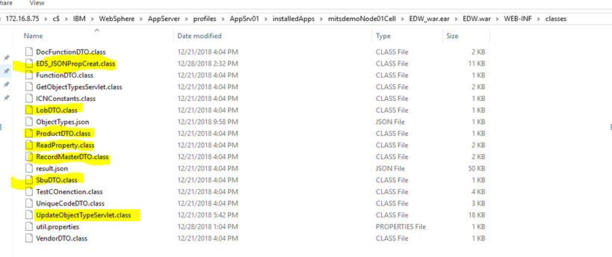

### Database Tables Required :

1. SBU
2. LOB
3. PRODUCT
4. RECORDMASTER
5. ENTITY

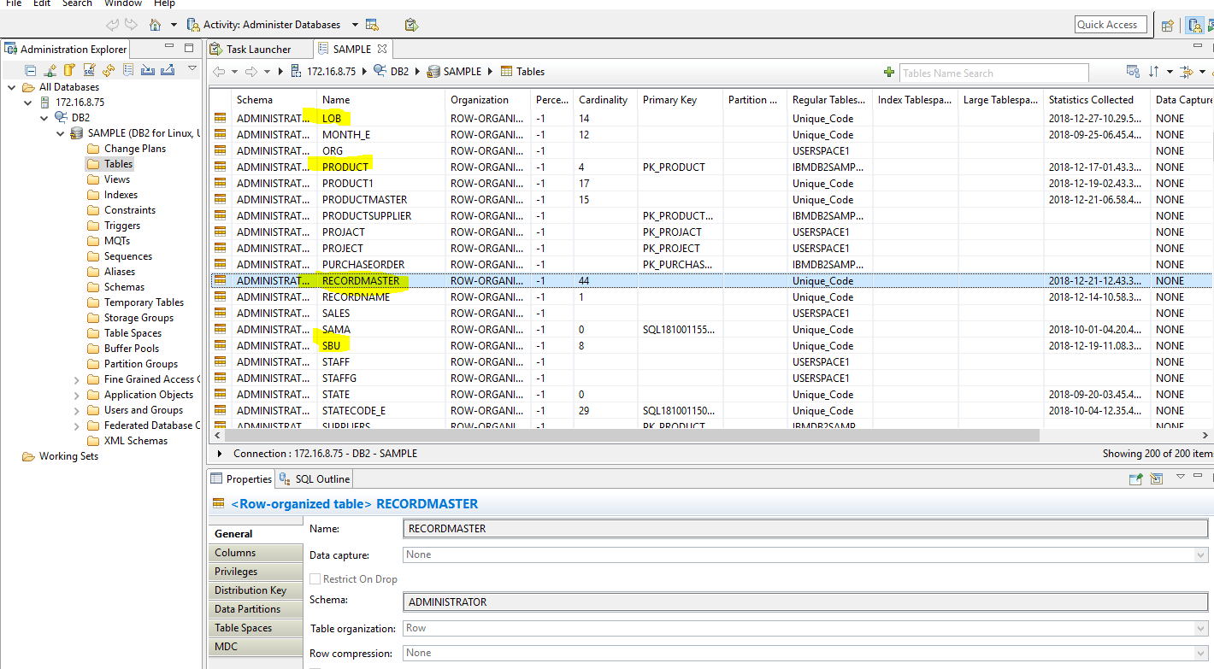

## FDM Artifacts

### DMS Class

1.Created Document class name with “**DMS**” and Workflow name with ‘**EdelweissDMS**’ .

To create a documents class follow the below steps.

* Open **Administration console for content engine** and go to document class, select new class as below.

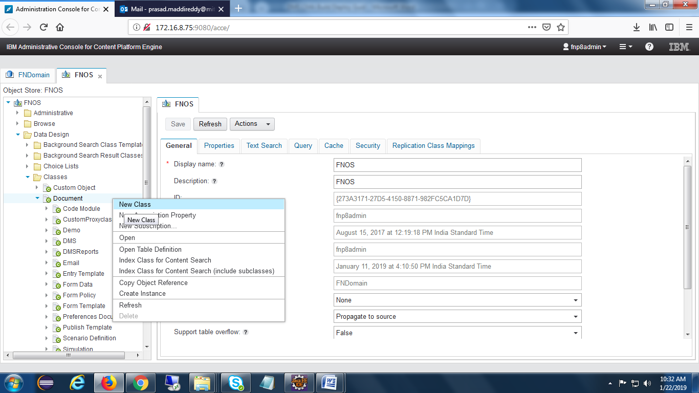

Provide name of the class ,then click on next and finish buttons.

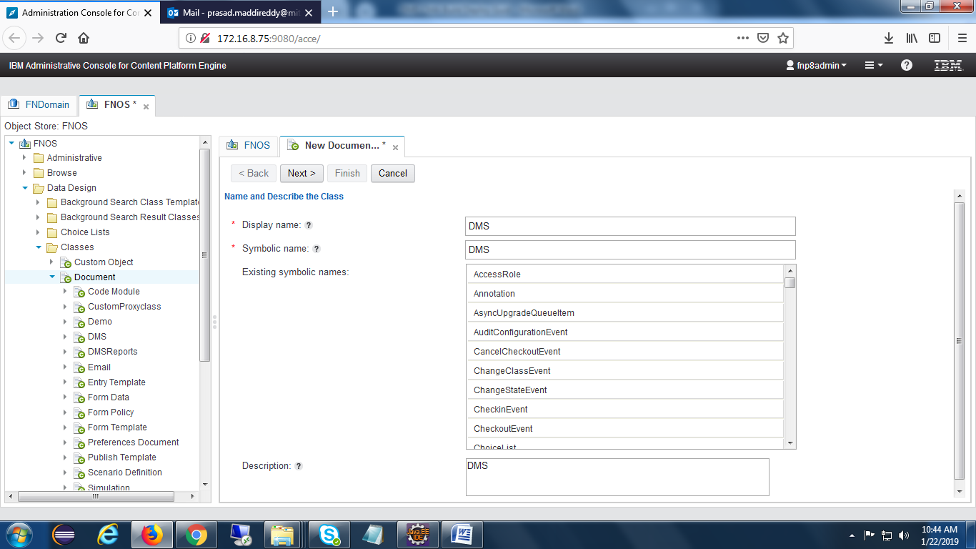

### Entry Template for DMS class

Open Navigator desktop and select **Open Entry Template View** feature.

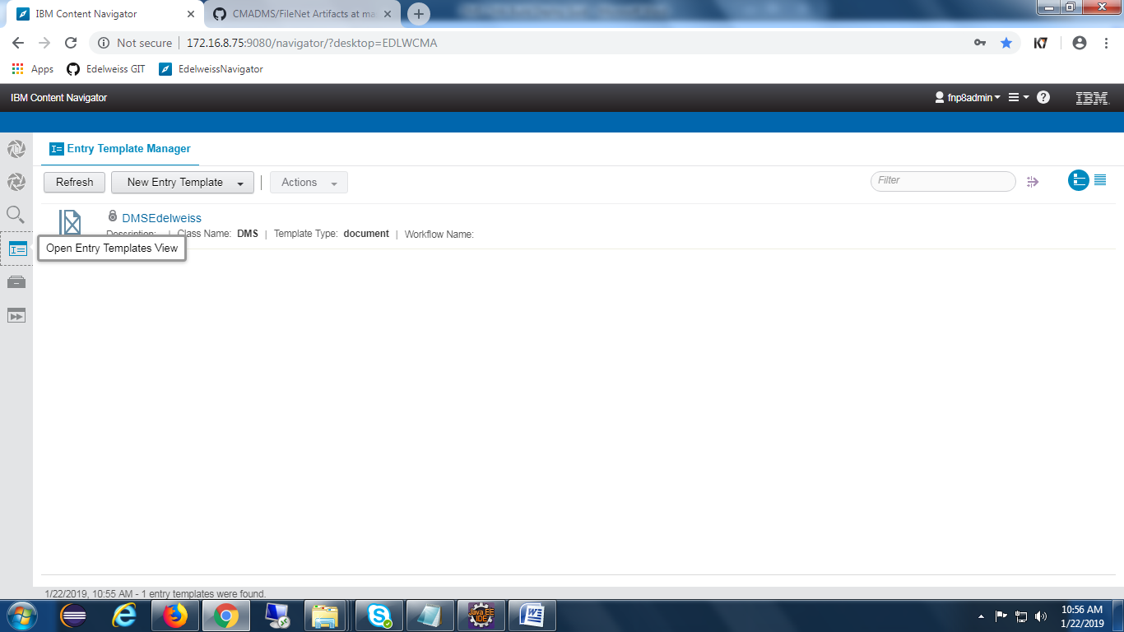

Click on New Entry Template Button and select document entry template as shown in the below screen.

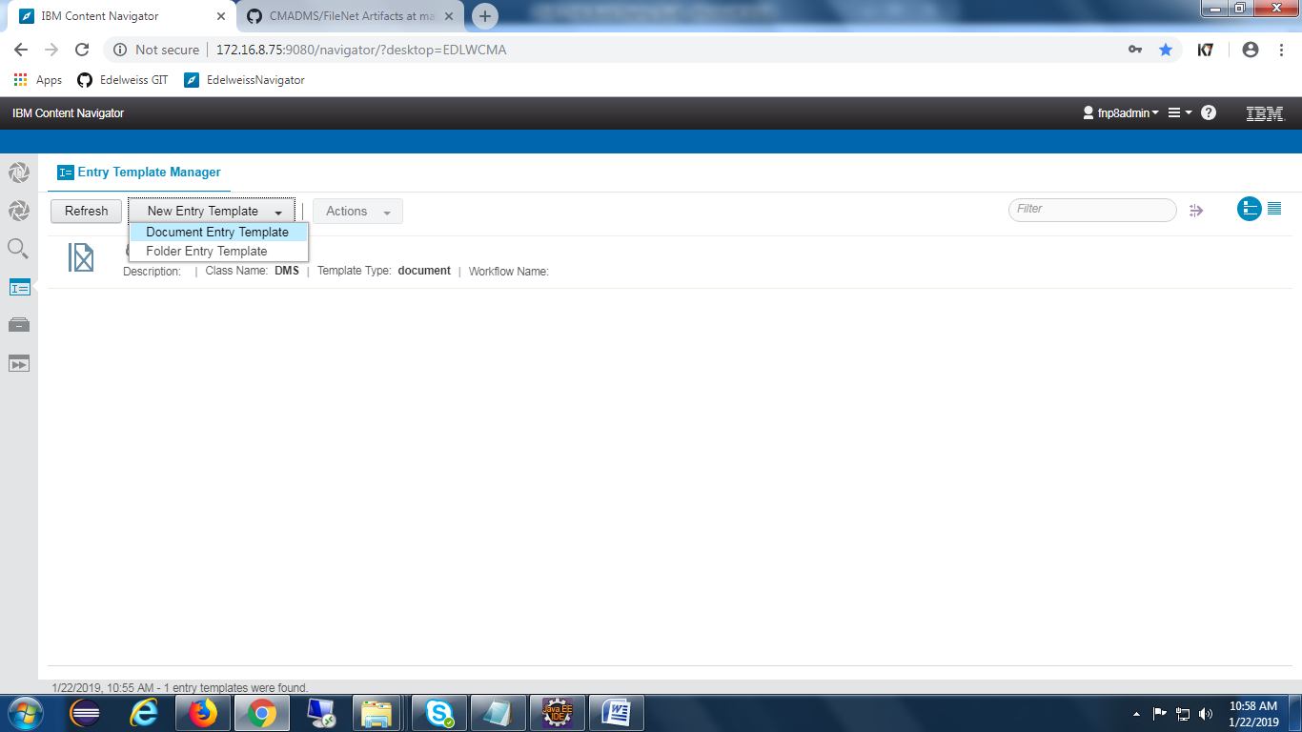

After selection of Document Entry Template below screen will appear.

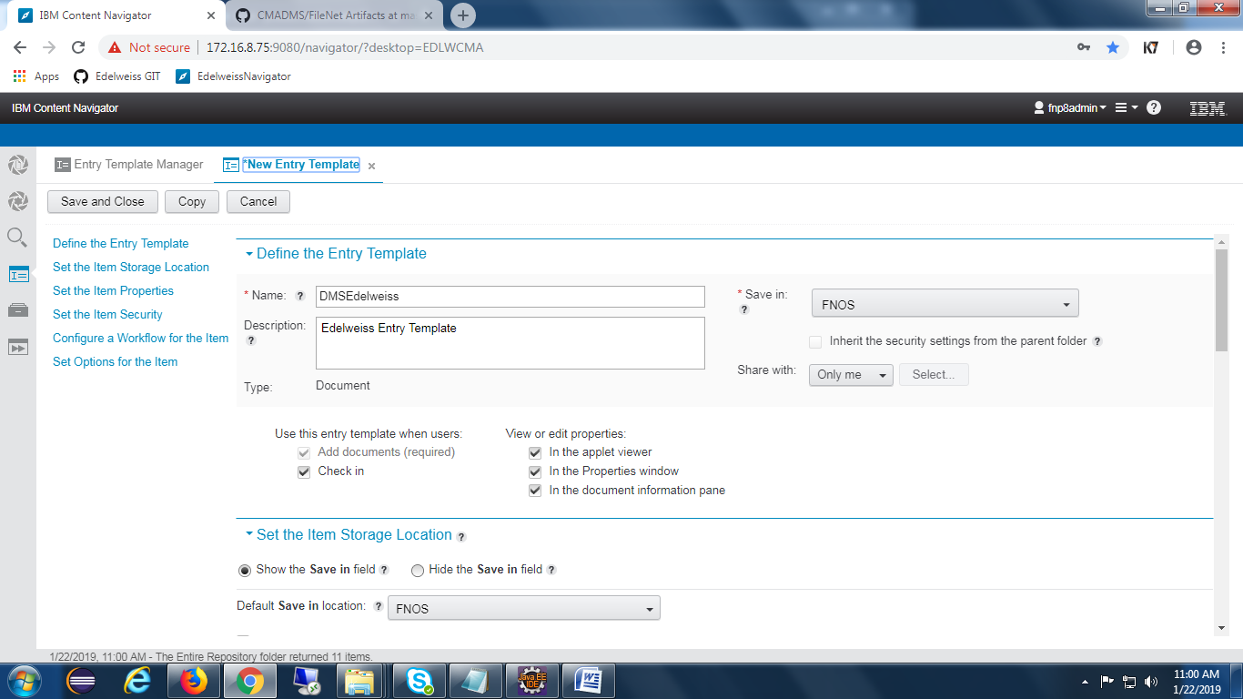

Click on edit layout and add all the required properties as below.

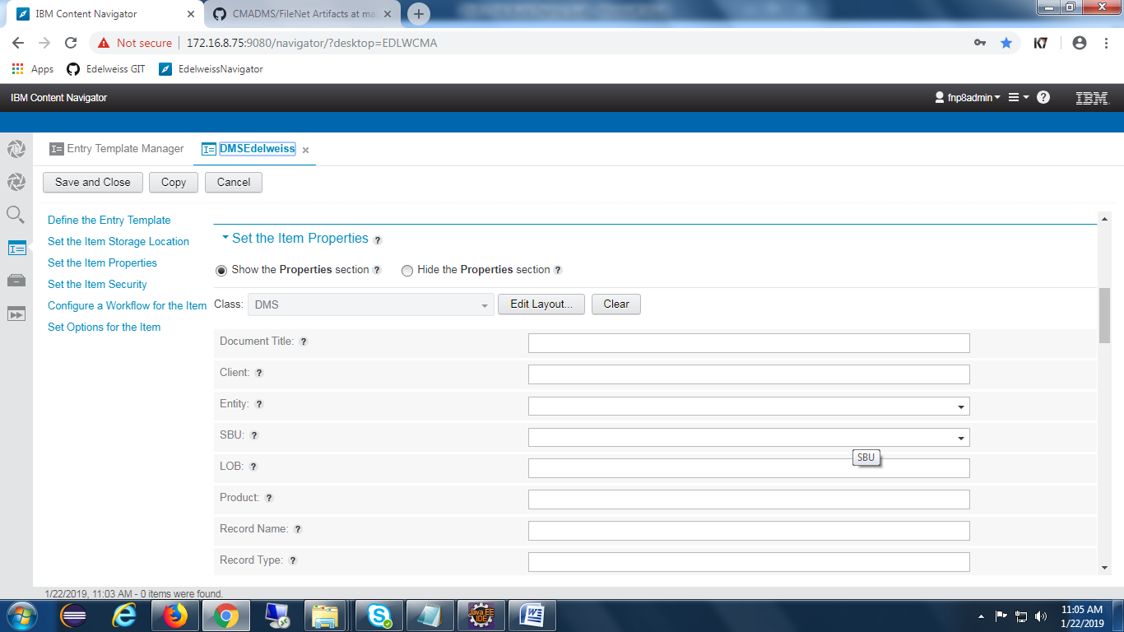

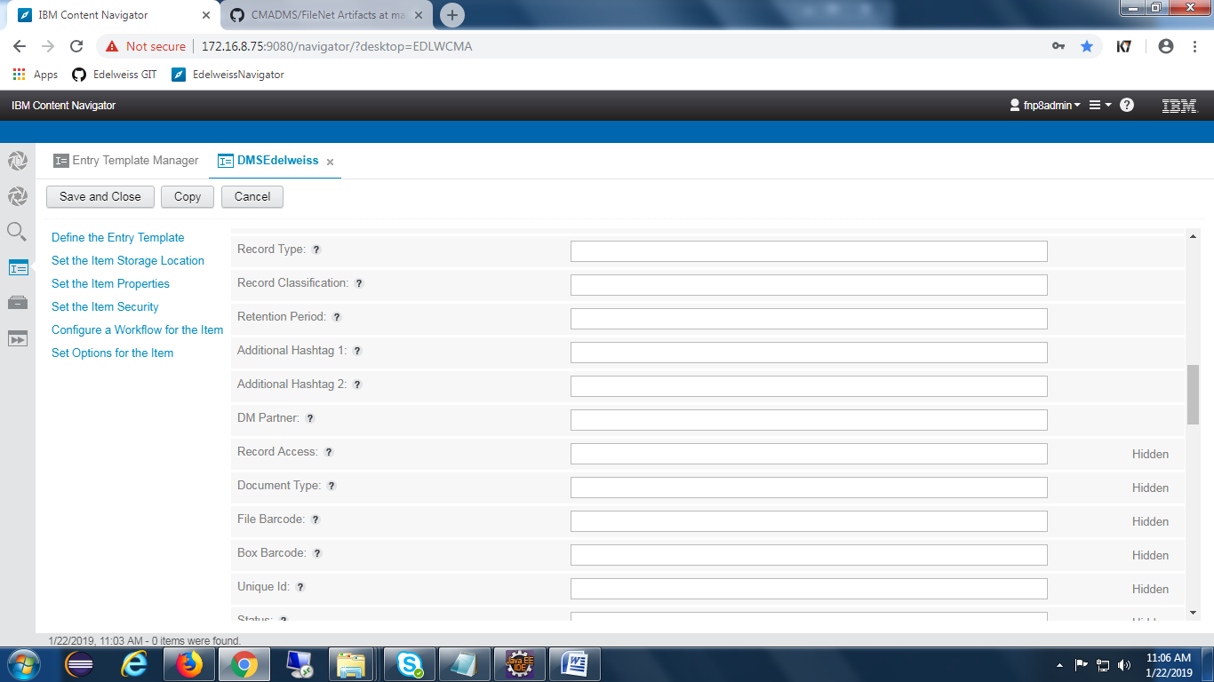

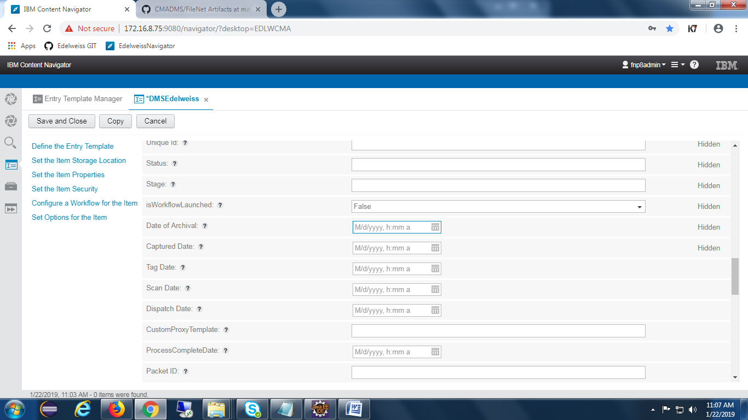

Provide security at the set item security tab, as shown in the below screen.

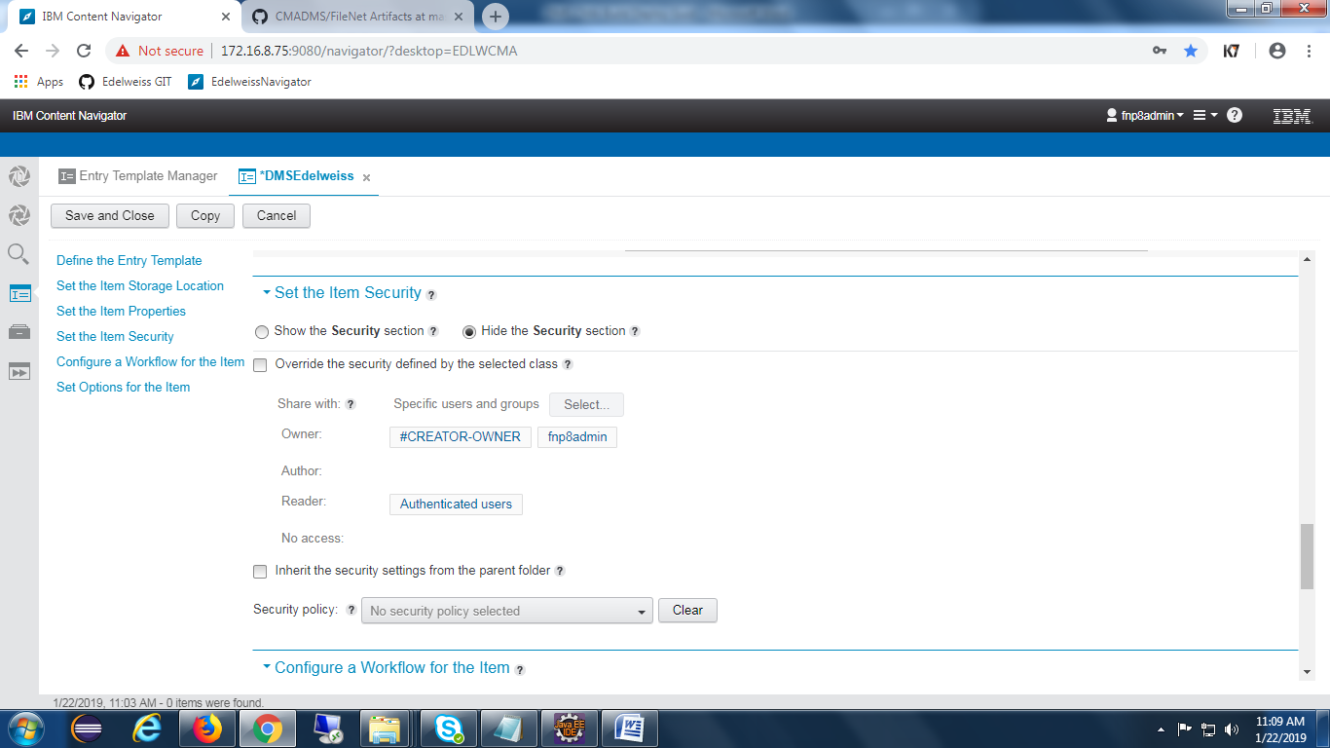

Click on Save and Close button to complete the creation of Entry template.

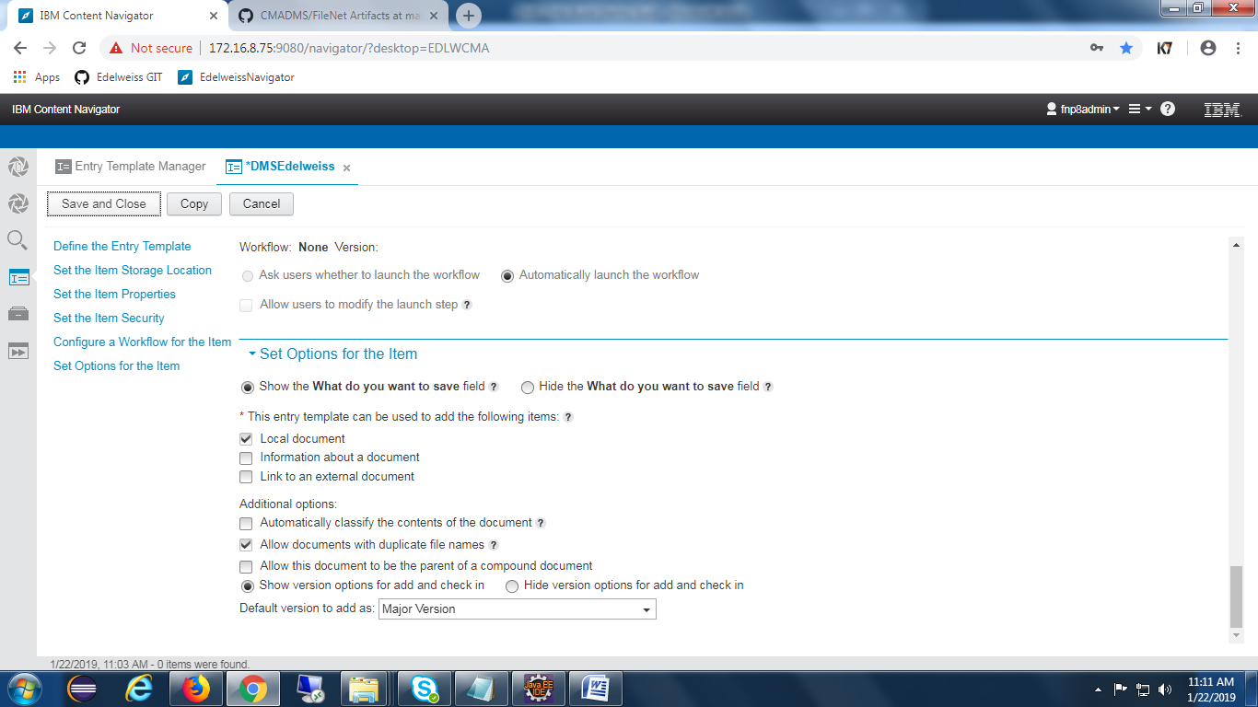

Once creation of entry template is completed , It will appear at Open Entry Template View feature as shown the below screen.

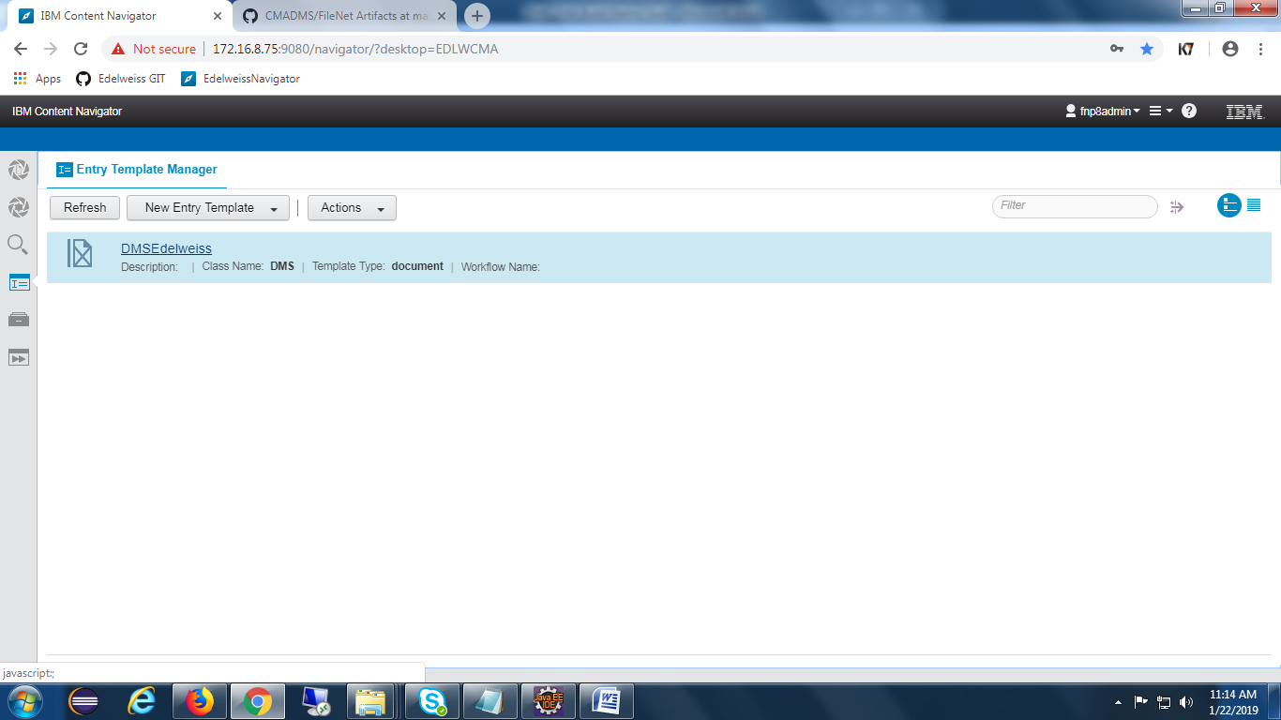

### Search Template for DMS

Open Navigator and click on **Open Search View** feature as shown in the below screen.

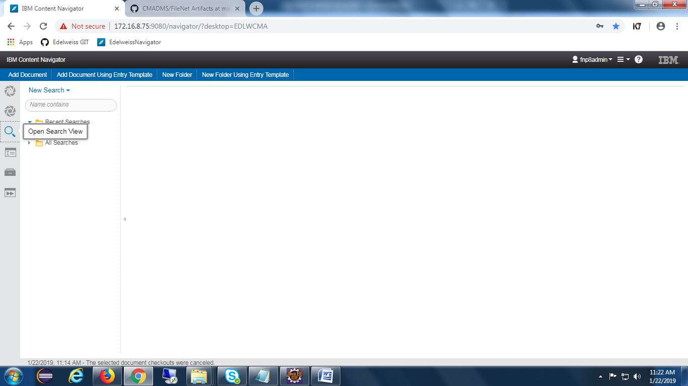

Click on New Search and add all the required search fields as shown in the below screen.

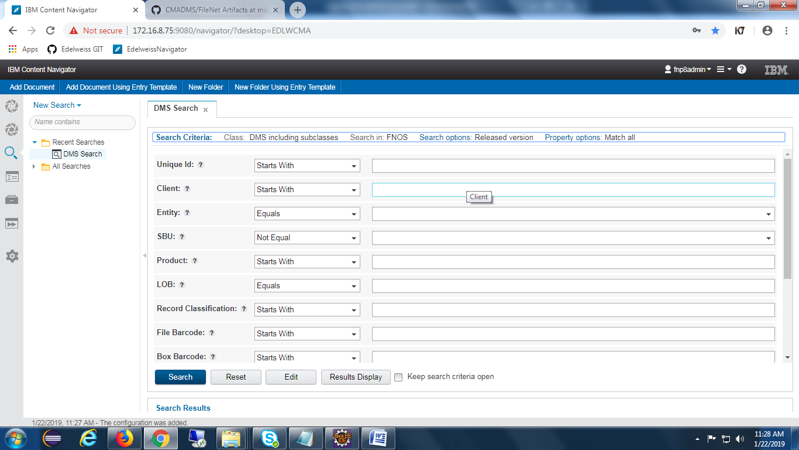

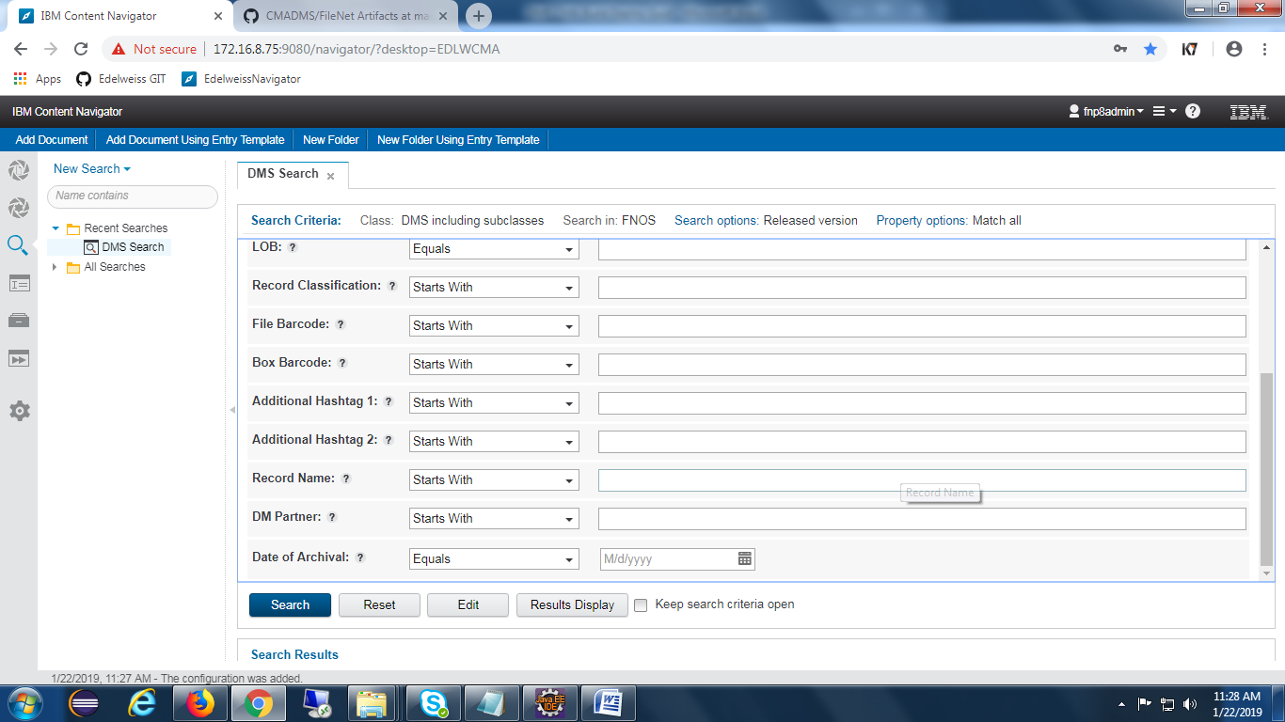

Click on Results Display button and add properties like below.

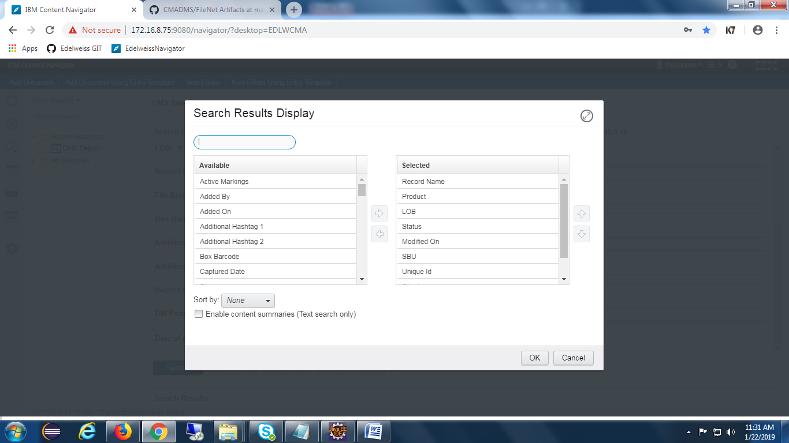

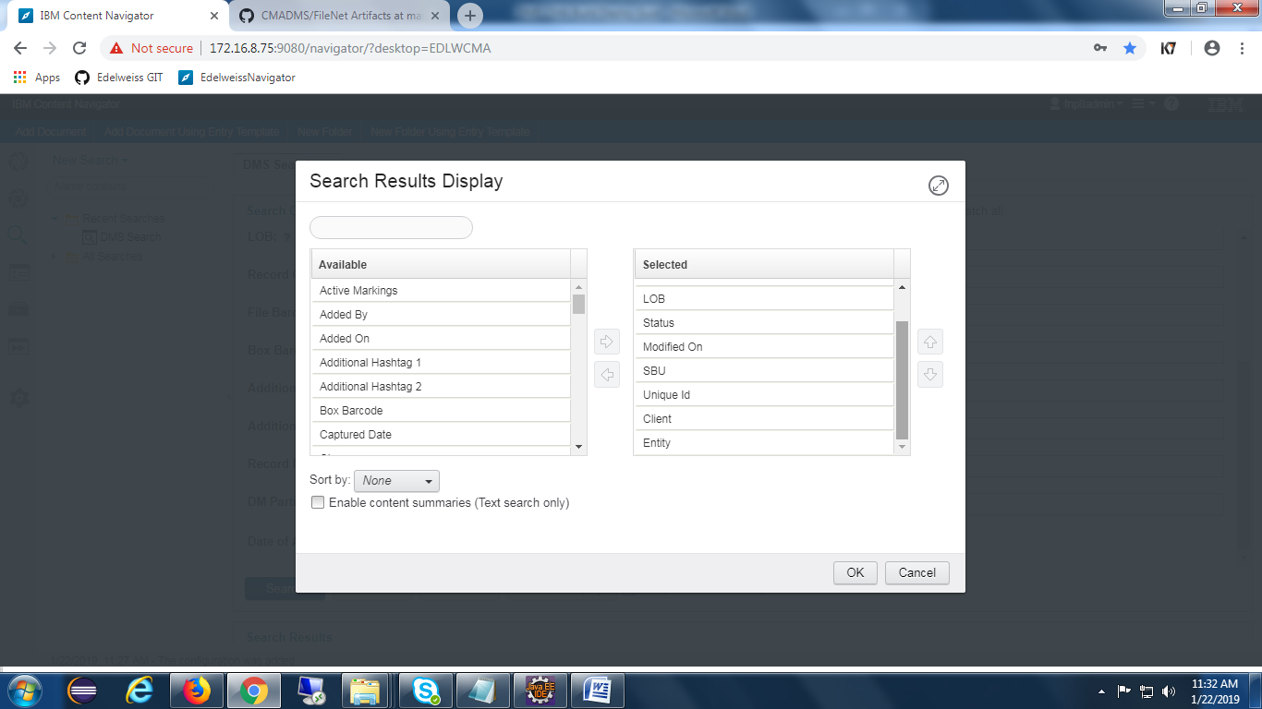

## PCC-Configuration

### Components Creation :

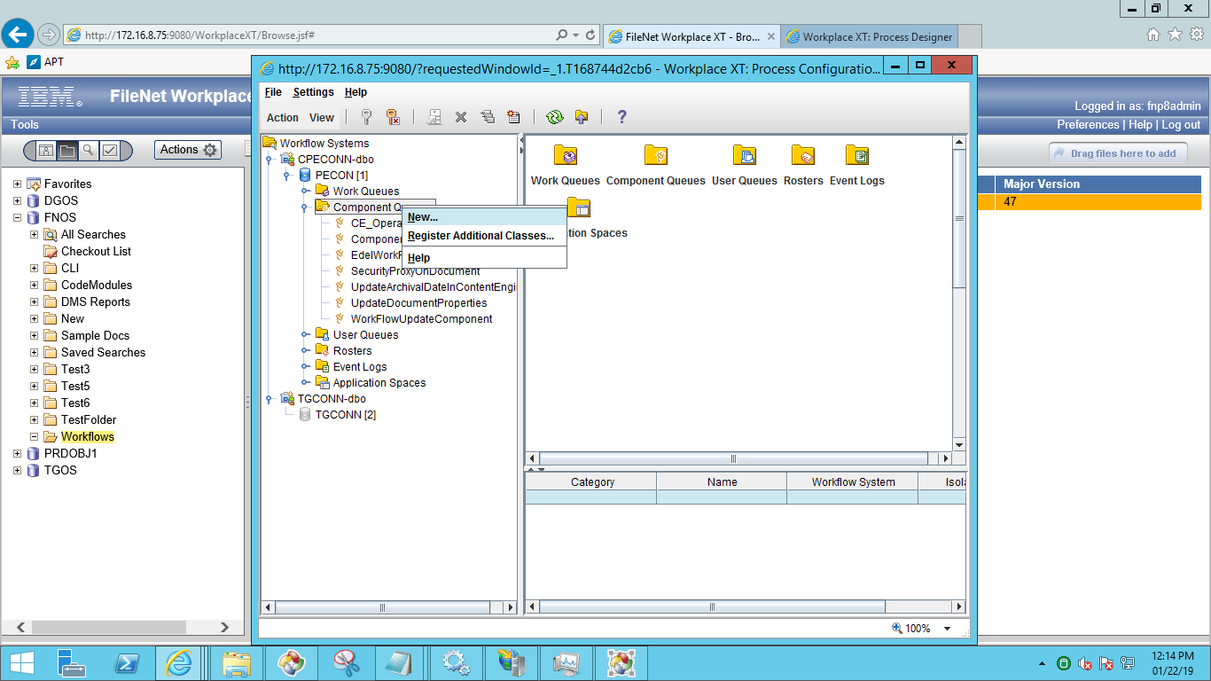

Provide appropriate Queue name as shown in the below screen and click on next button.

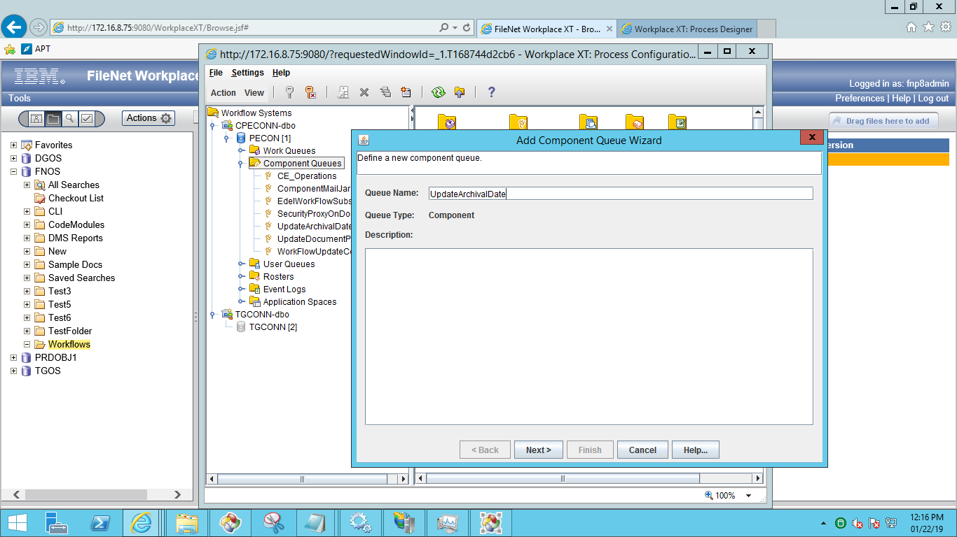

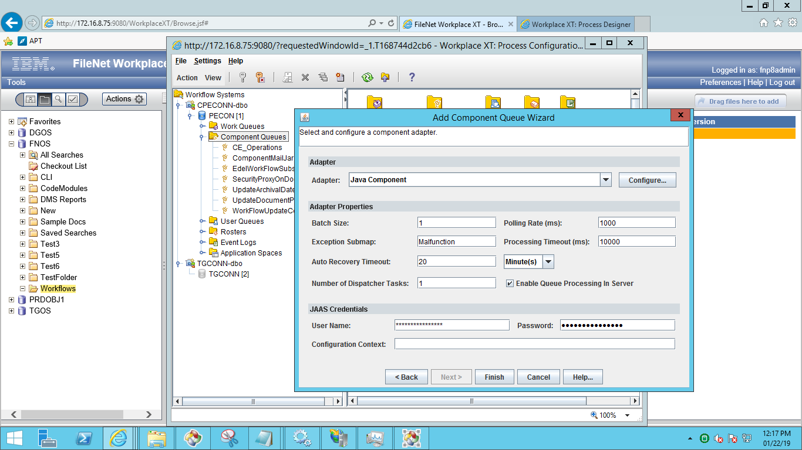

click on configure and select code module and class name of the component.

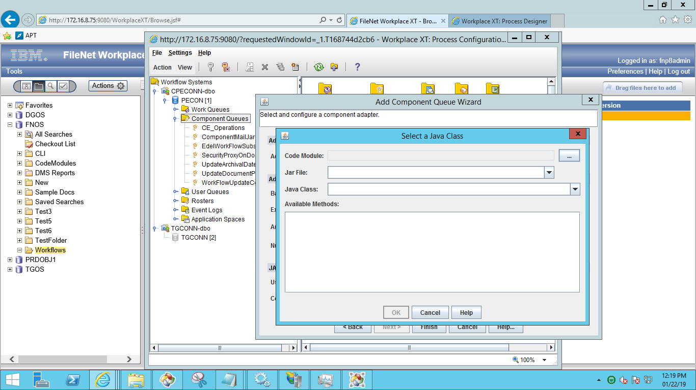

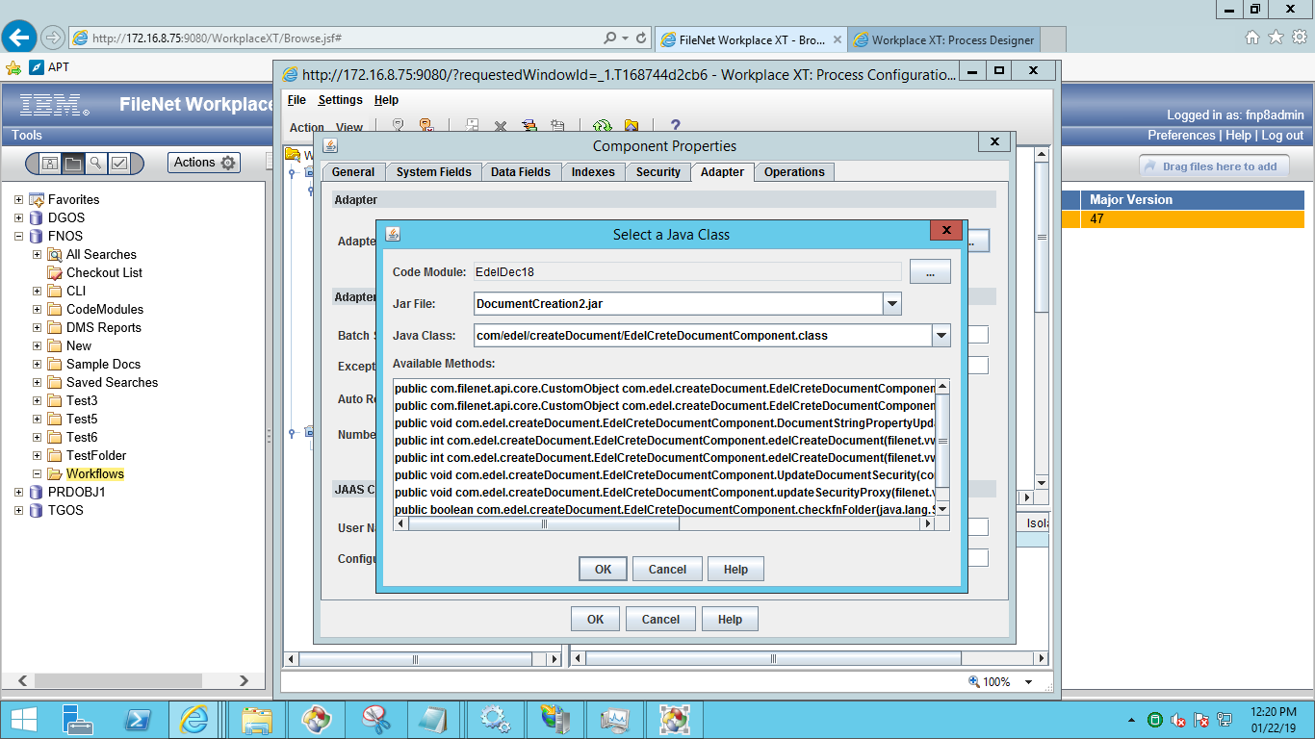

Click on OK button and go to properties tab and expose all the methods in it as shown in the below screen.

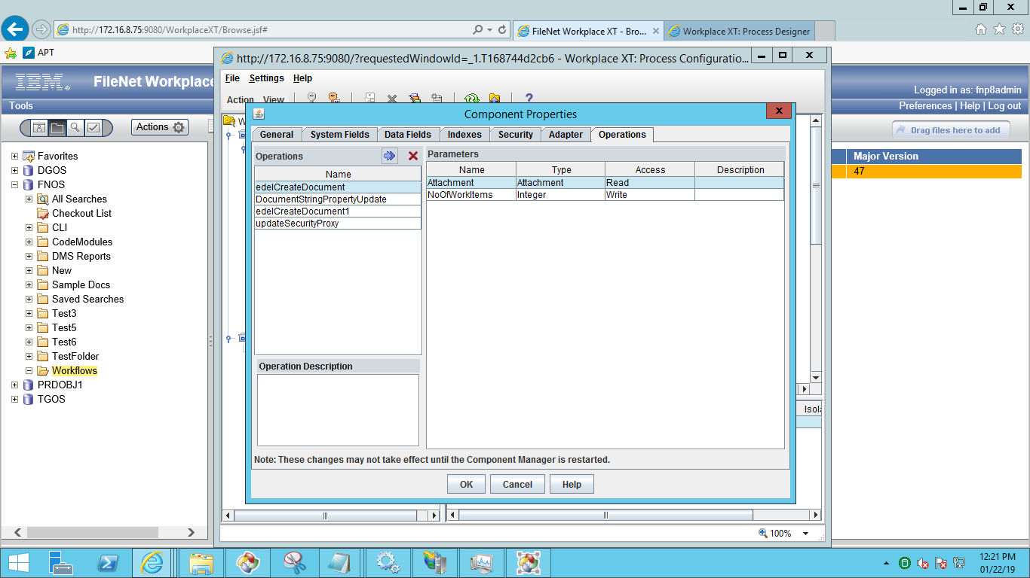

1. Workflowupdatecomponent

It helps the system to create a new version if the Client and Product is same.

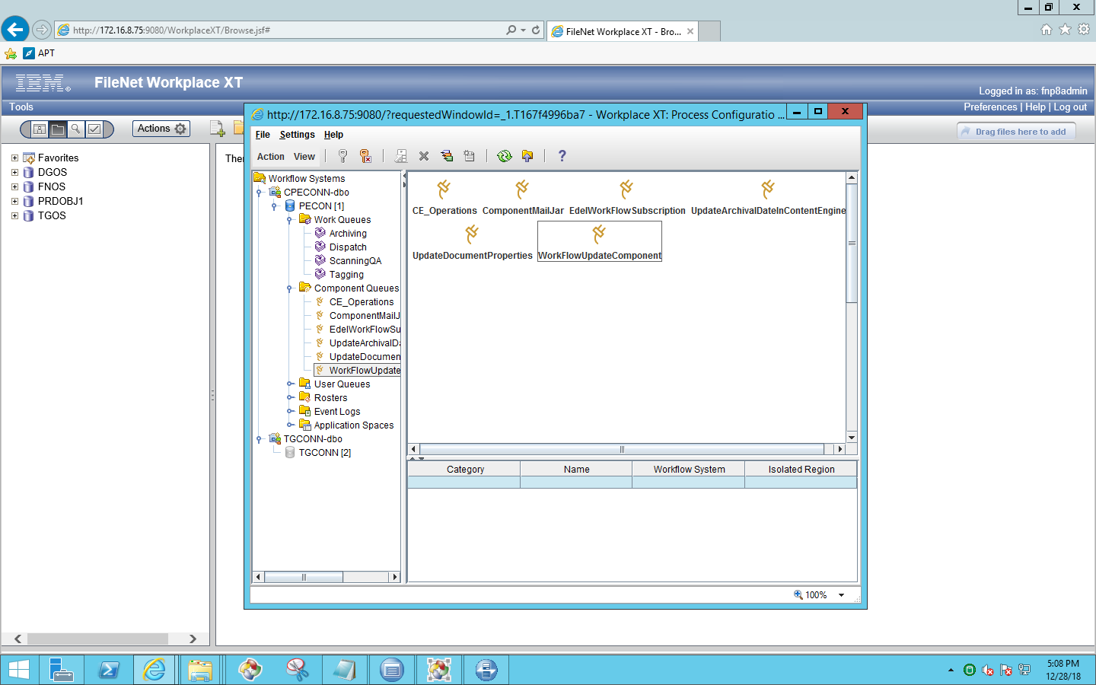

Click on adopter , then we will find below screen

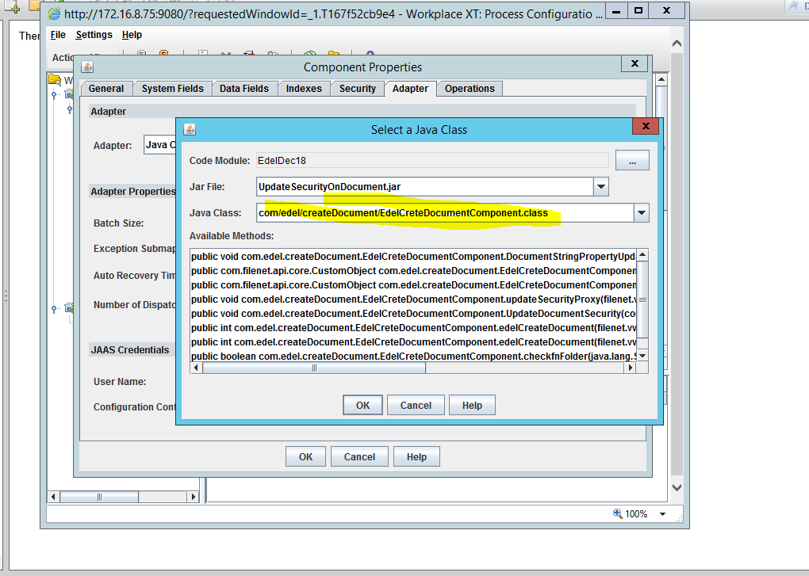

Click on properties , then we will find below screen

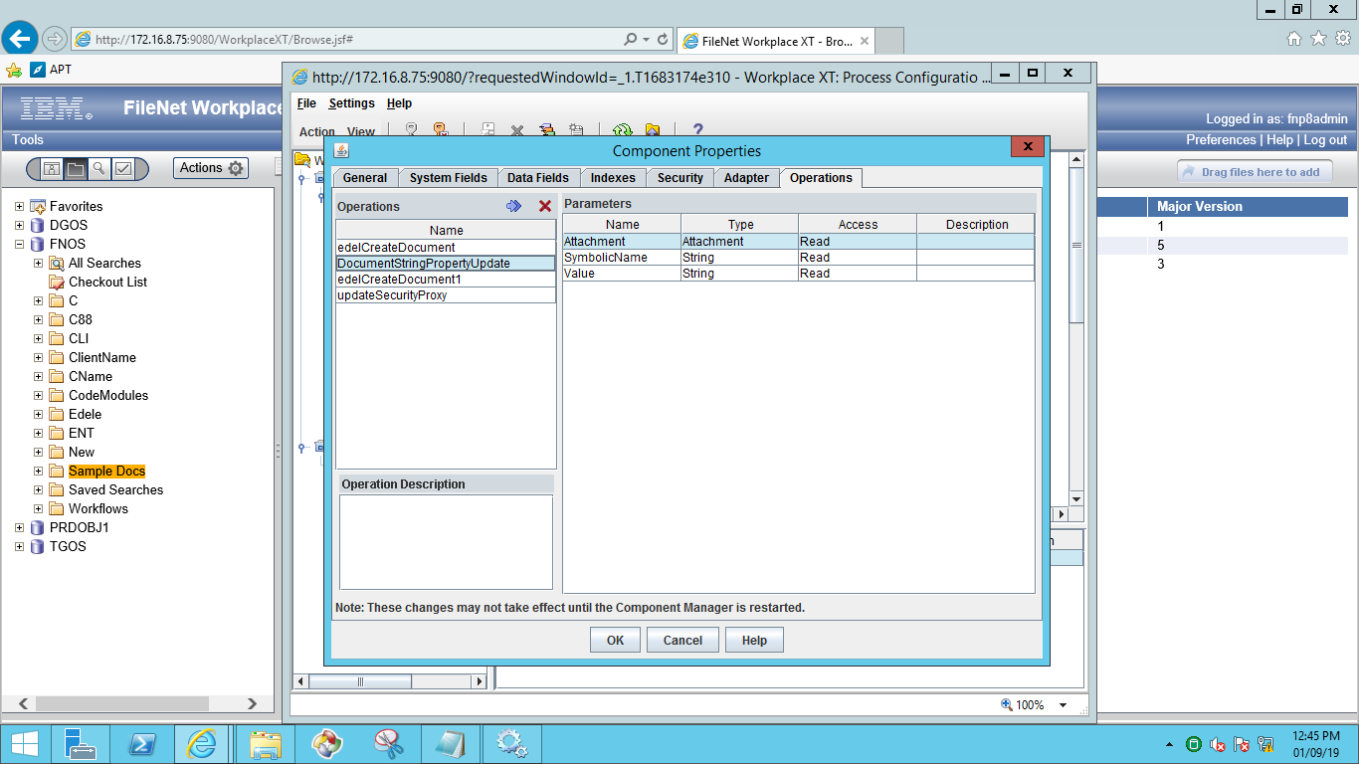

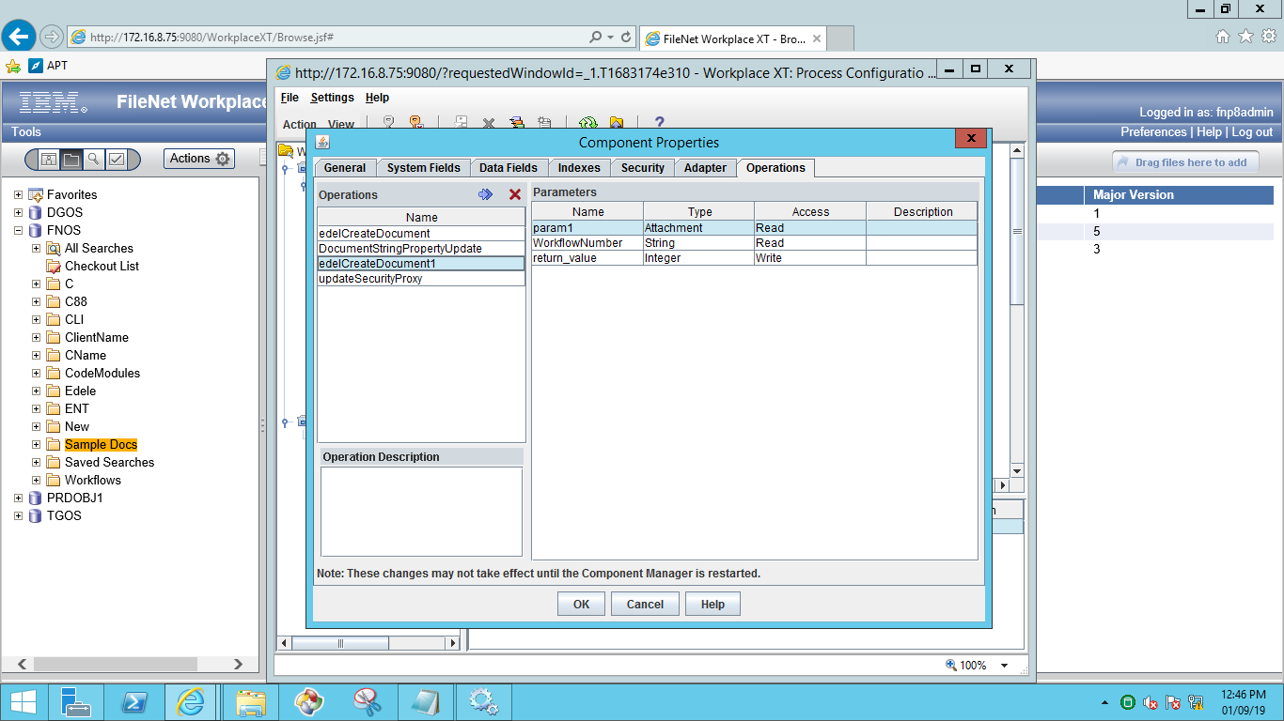

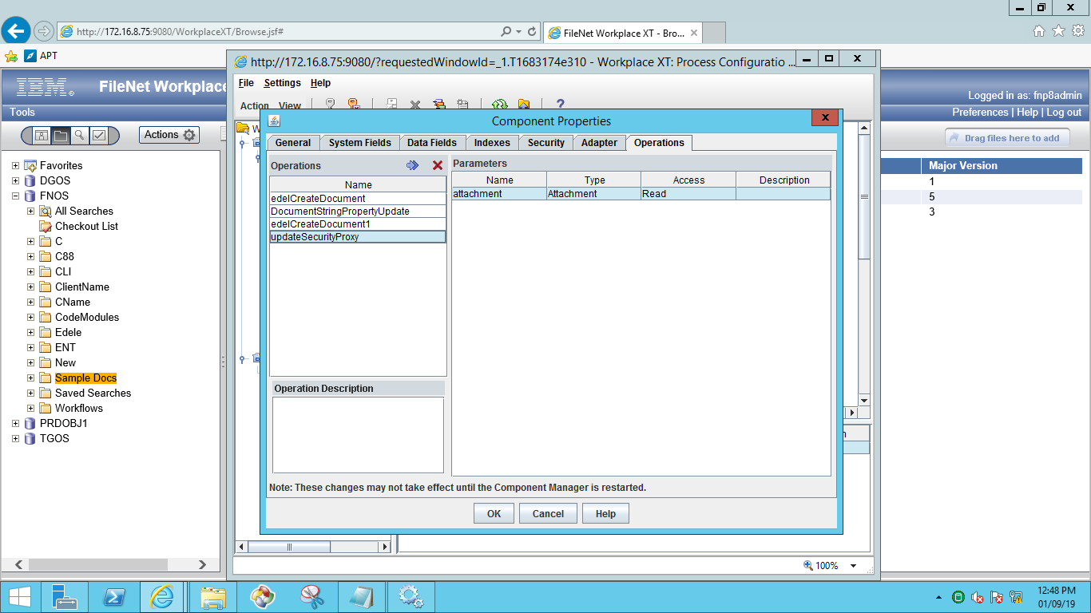

1. UpdateArchivalDateInContentEngine

It helps the system to update Archival date on document once the Archival step is completed.

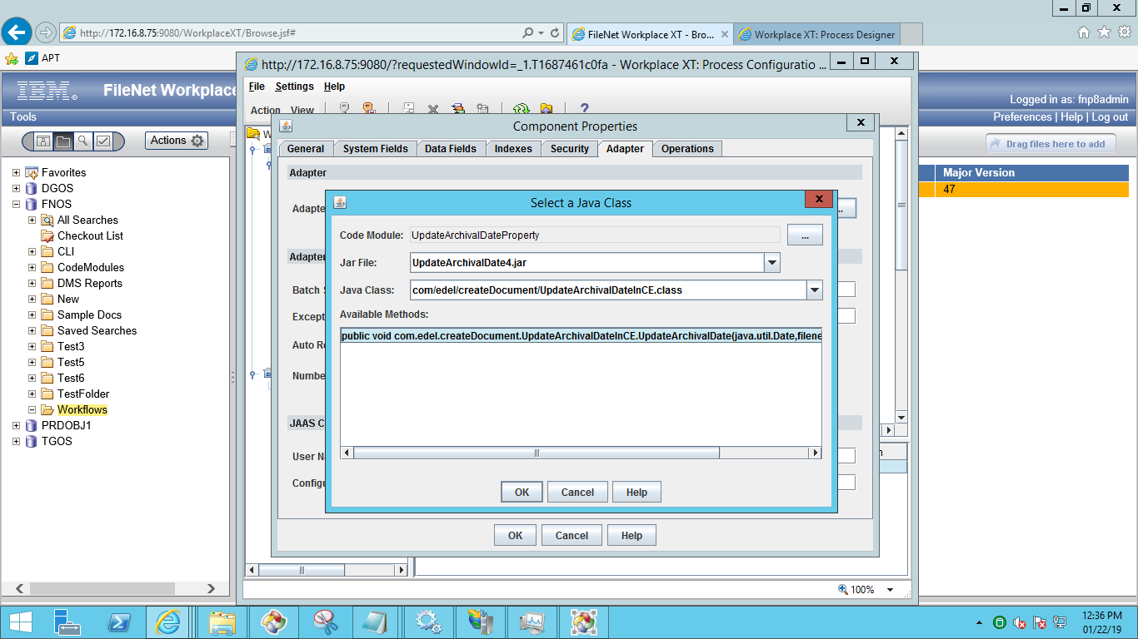

Below are the methods consisting for this component.

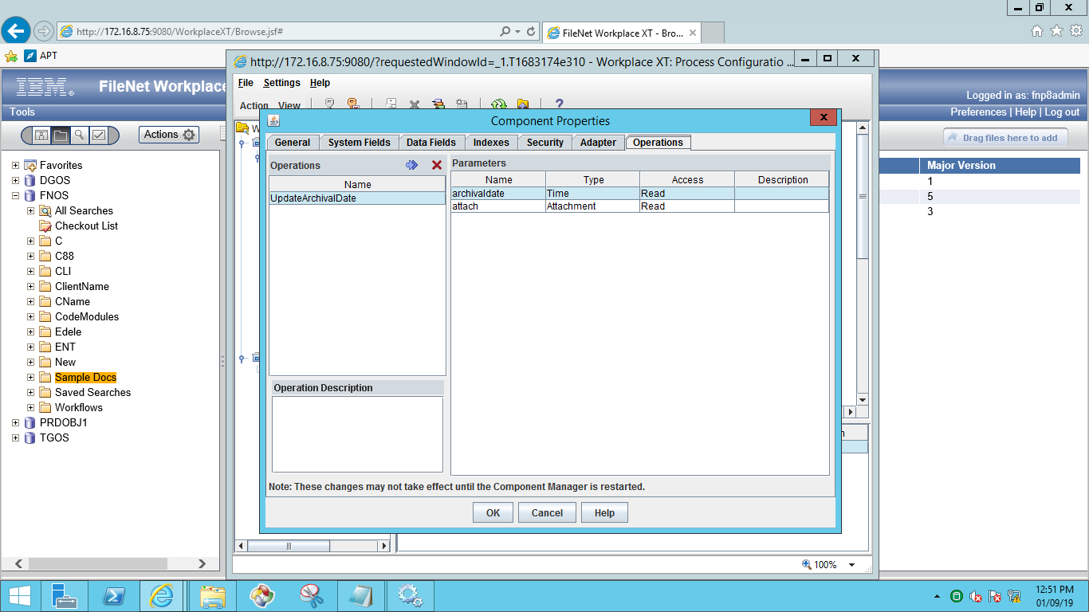

1. UpdateDocumentProperties

This component helps the system to update Dispatch date on Document.

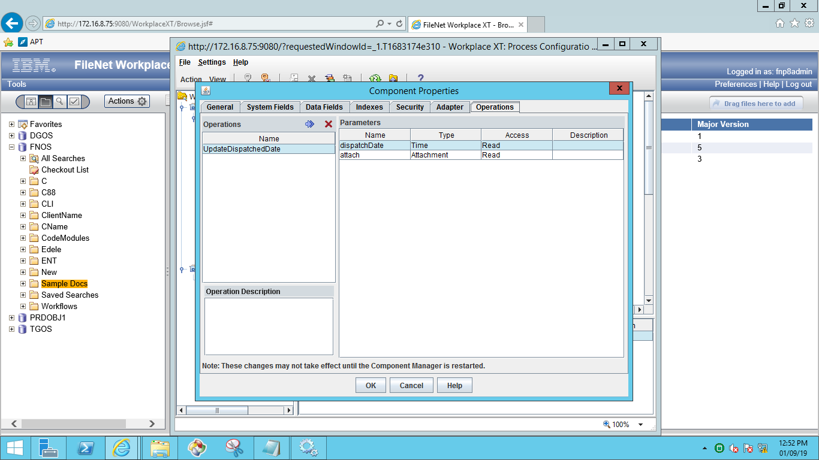

### Property File Path:

Property File Path: C:\Edel\CreateDocument.properties

### In-basket Details.

1. Created In-basket’s for different roles.
   * 1. Processing
     2. Archival
2. Processing step: In-basket name is ‘Processing’ and “Scanning QA” is the Queue name .
3. Dispatch step: In-basket is ’Archival’ and “Archiving” is the Queue name .
4. Archive step: In-basket is ’Archival’ and “Archiving” is the Queue name .

**Note**: Same In-basket and Same Queue used for above two –steps.

### Work Queues

Create below Work queues and Inbaskets.

* Archiving
* ScanningQA

**Procedure to create work queues:**

Open WorkplaceXT and go to process configuration console and select **work queue** to create new one.

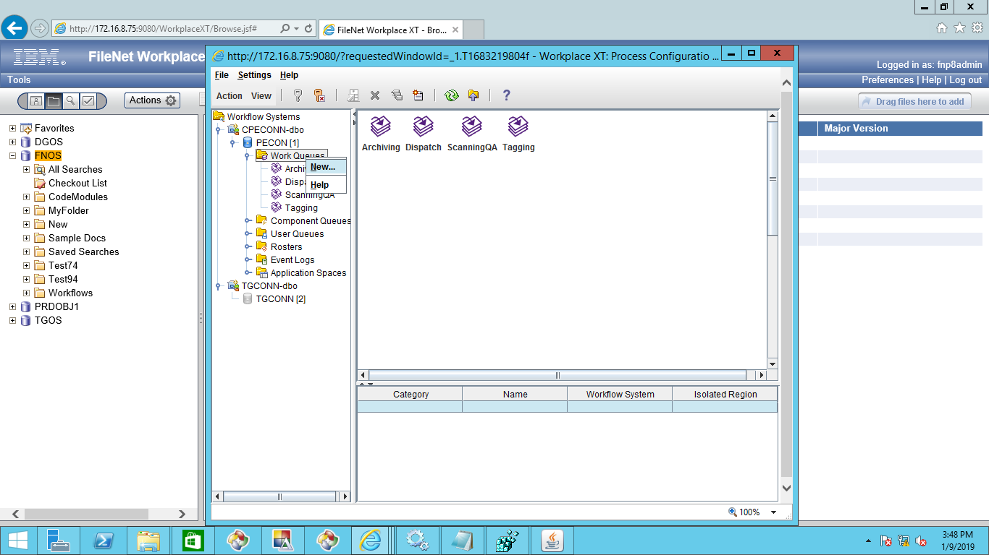

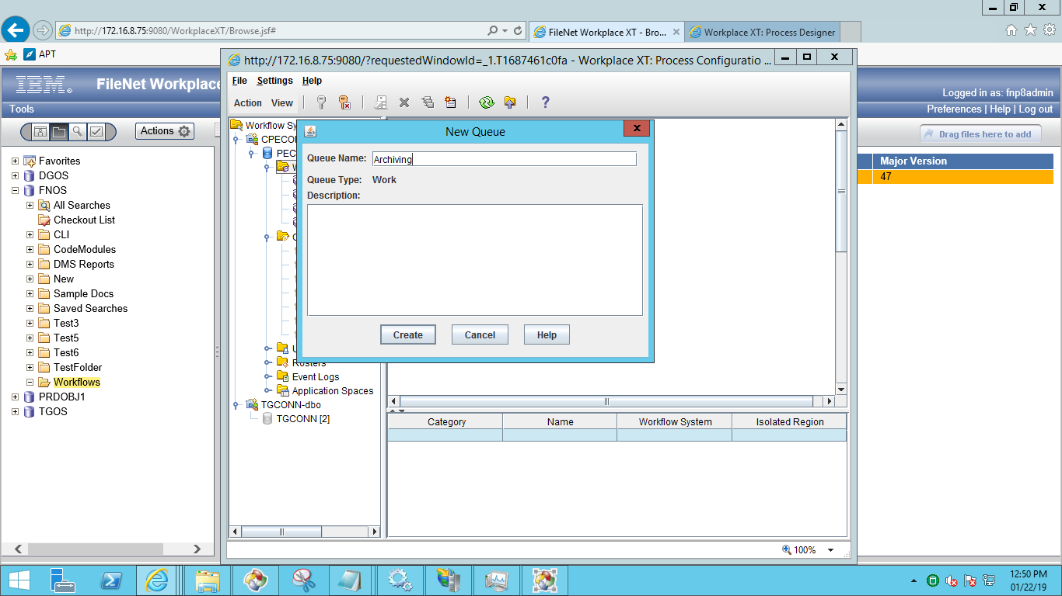

After creation of work queue ,go to data fields and add required fields as below,

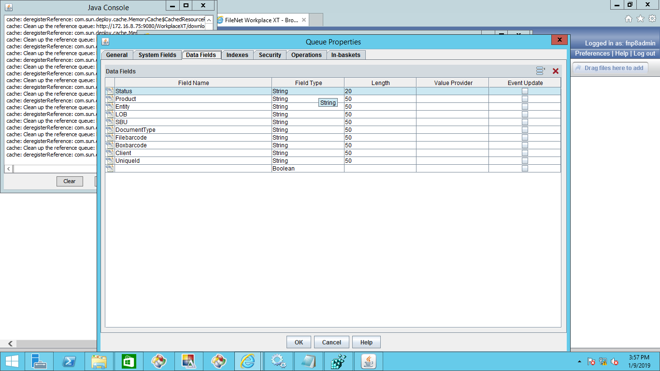

After adding the data fields click on inbasket and create inbasket and add the data fields as shown in below screen.

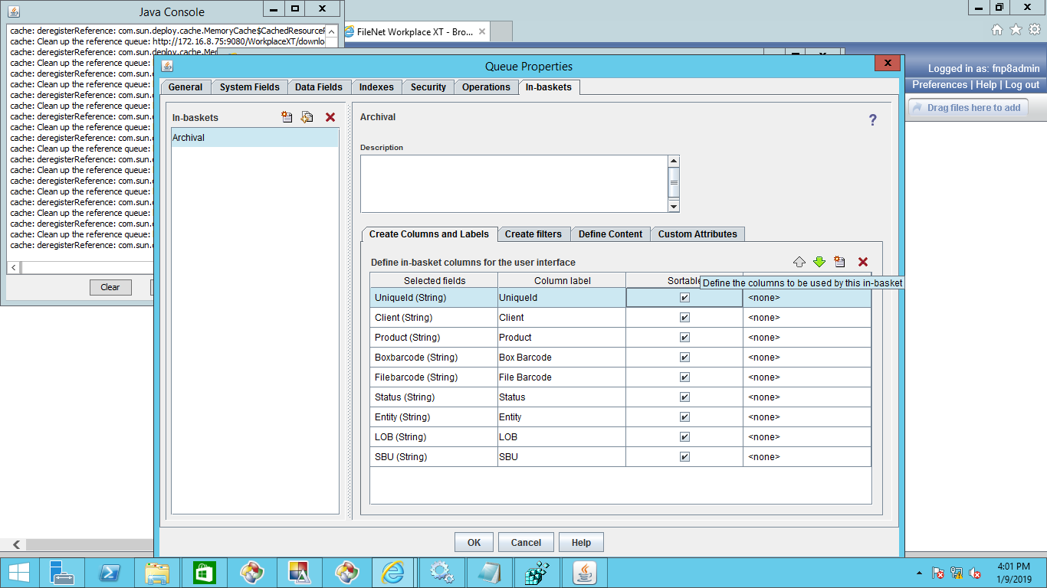

Same procedure for both the work queues.

### In-baskets

Below are the In-baskets for roles.

* Processing
* Archival

Open WorkplaceXT and select work queue and click on properties and choose Inbasket tab as shown in the below screen. Here add all the properties required for the inbasket.

For **ScanningQA** work queue **Processing** is the Inbasket name.

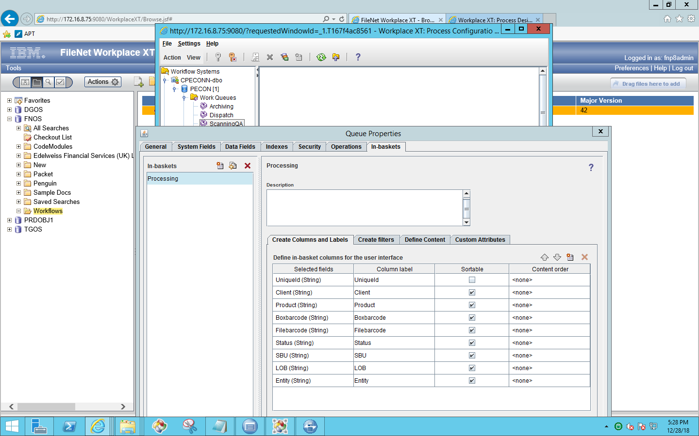

For **Archiving** work queue **Archival** is the Inbasket name.

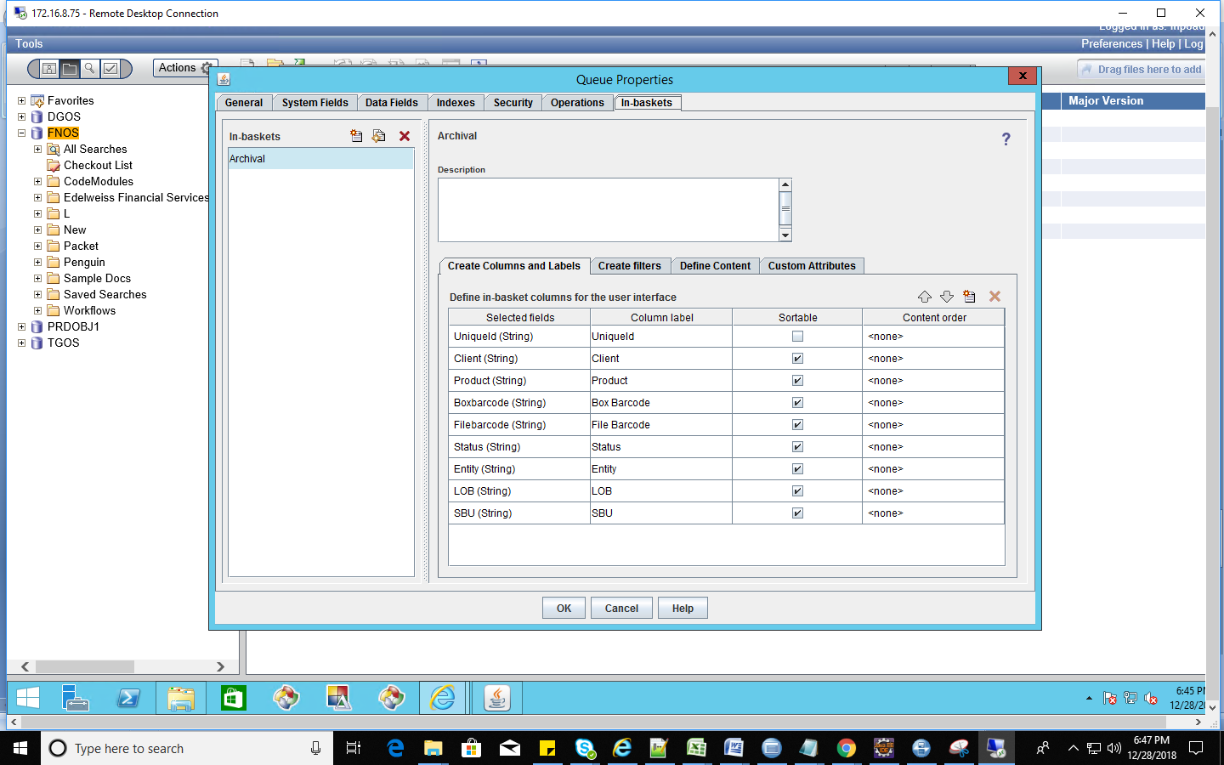

### Roles

Below are the two roles used.

* Archival
* Processing

Open WorkplaceXT and go to Process configuration console the below screen will appear.

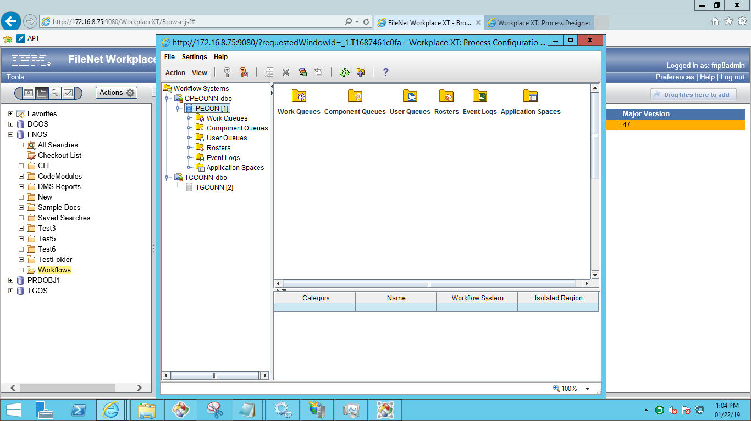

Here select application space folder and select application space and go to the properties of the application space.

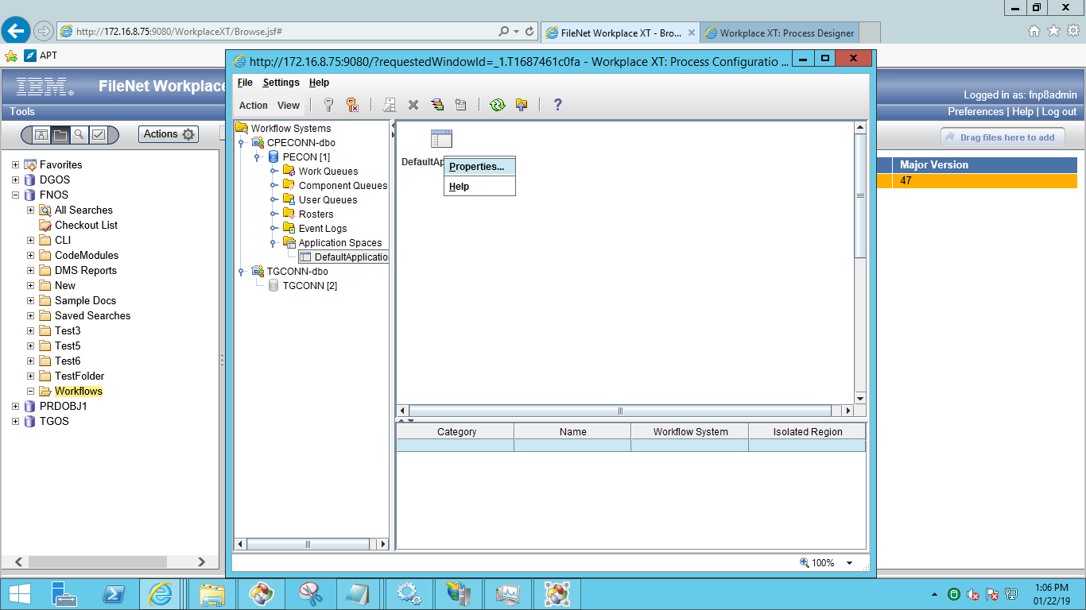

After clicking on properties below screen will appear. Click on Roles tab and select Inbaskets and add the users for the Inbasket as shown in the below screen.

Below screens helps for names of the Roles and Inbaskets names as well.

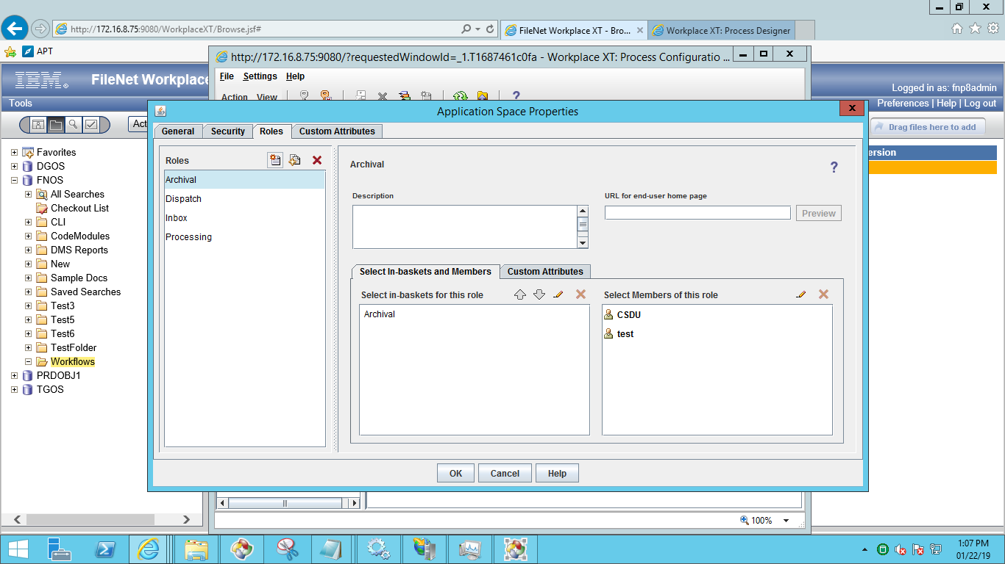

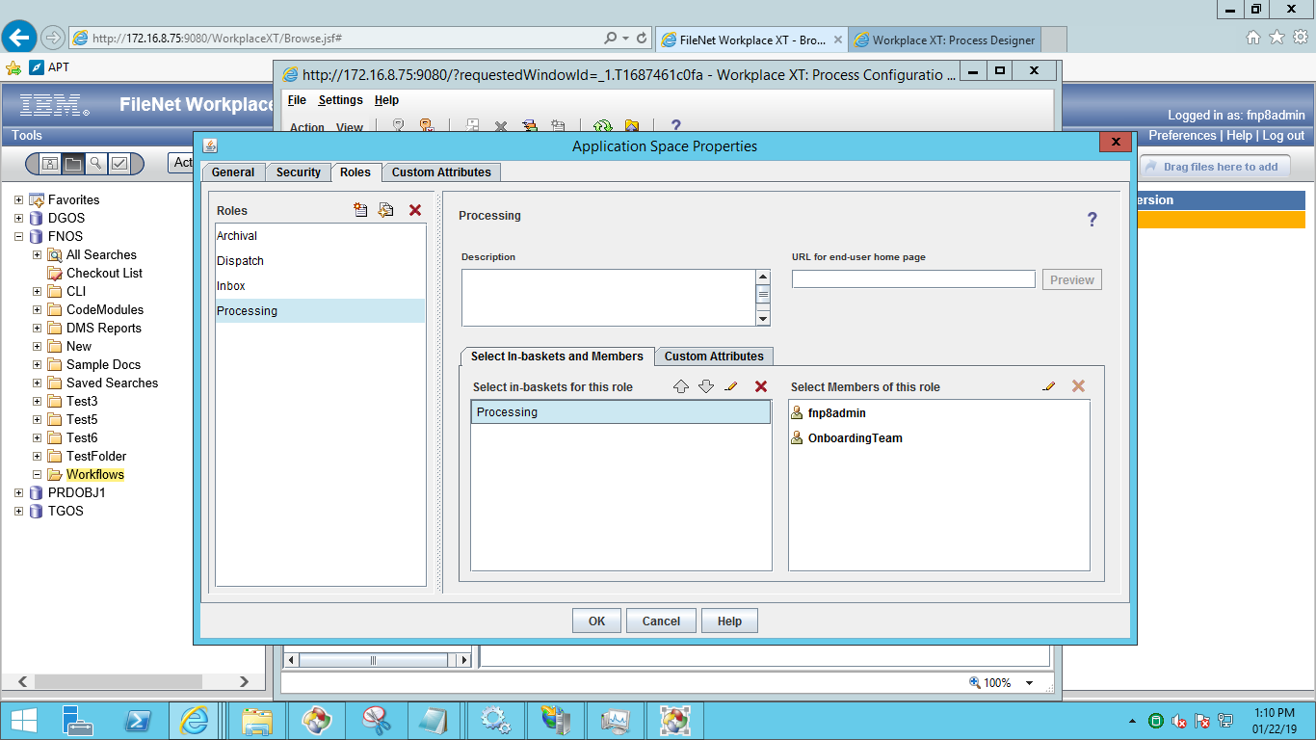

## Security Proxy

Create Proxy Class in Custom Object

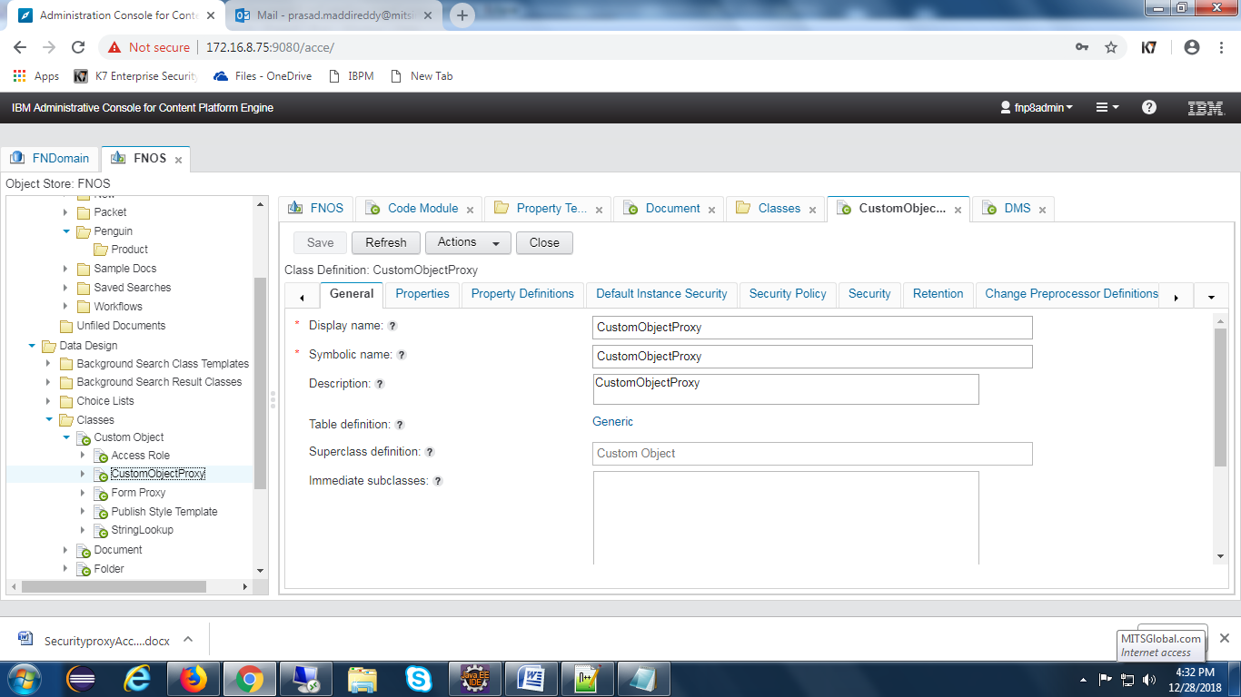

add Property **Title** to Custom Object class.

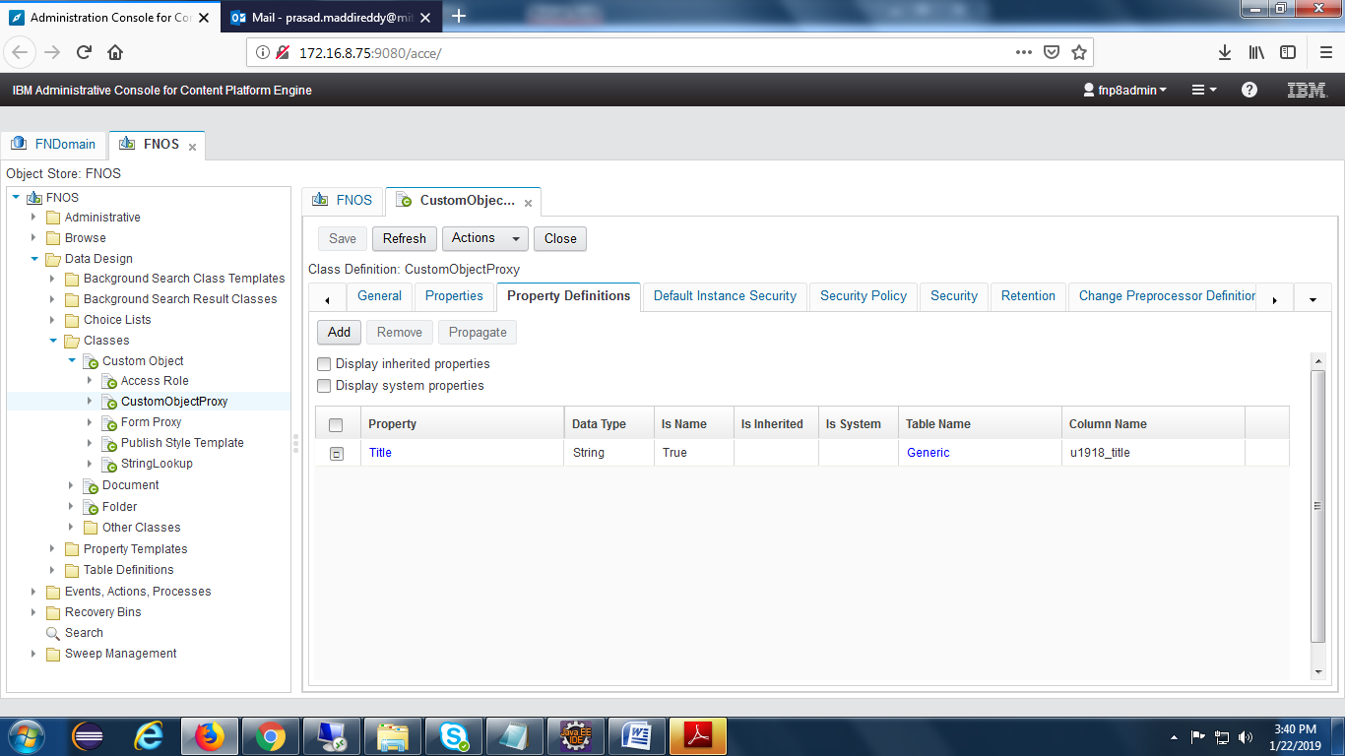

Create proxy property

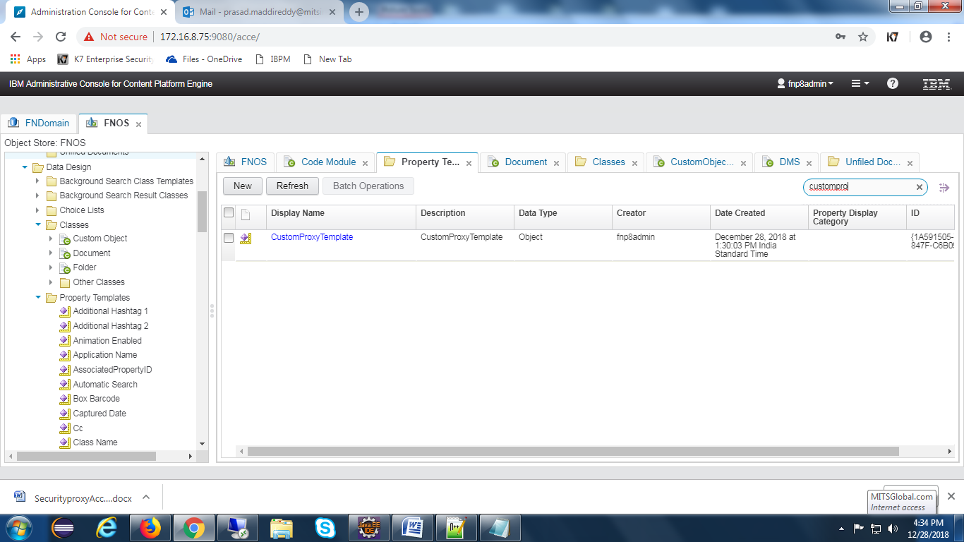

Add property to folder class

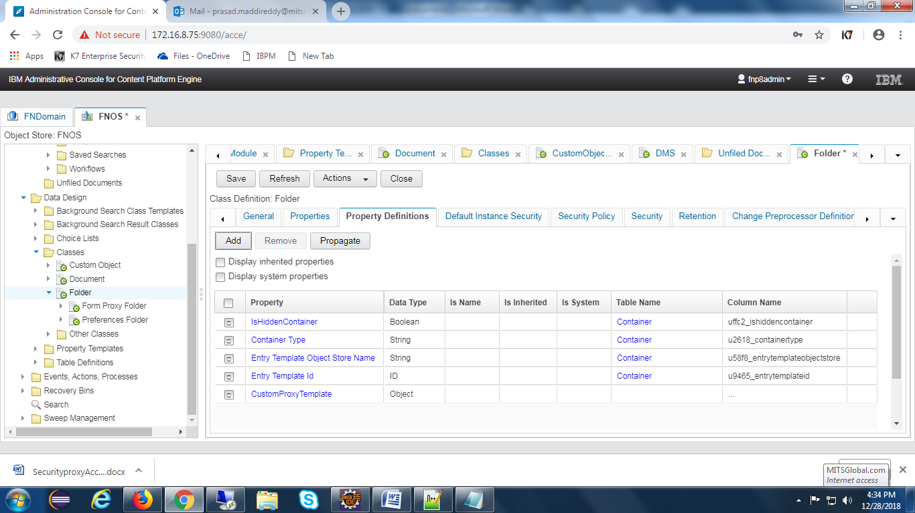

Set class type as CustomObjectProxy to the property

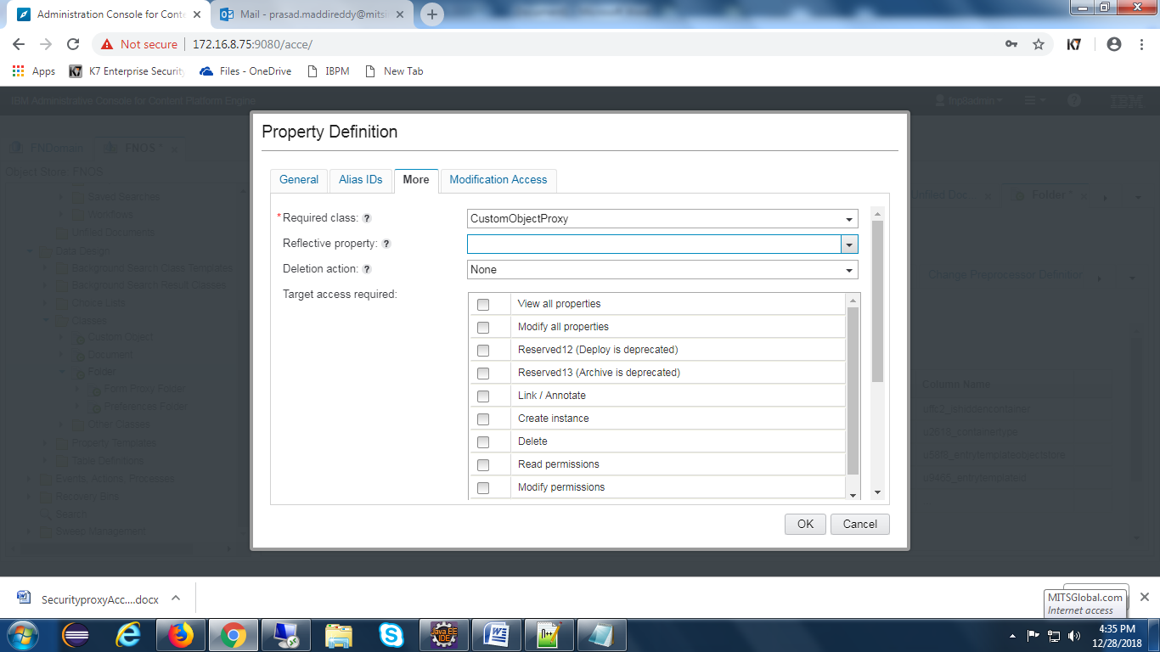

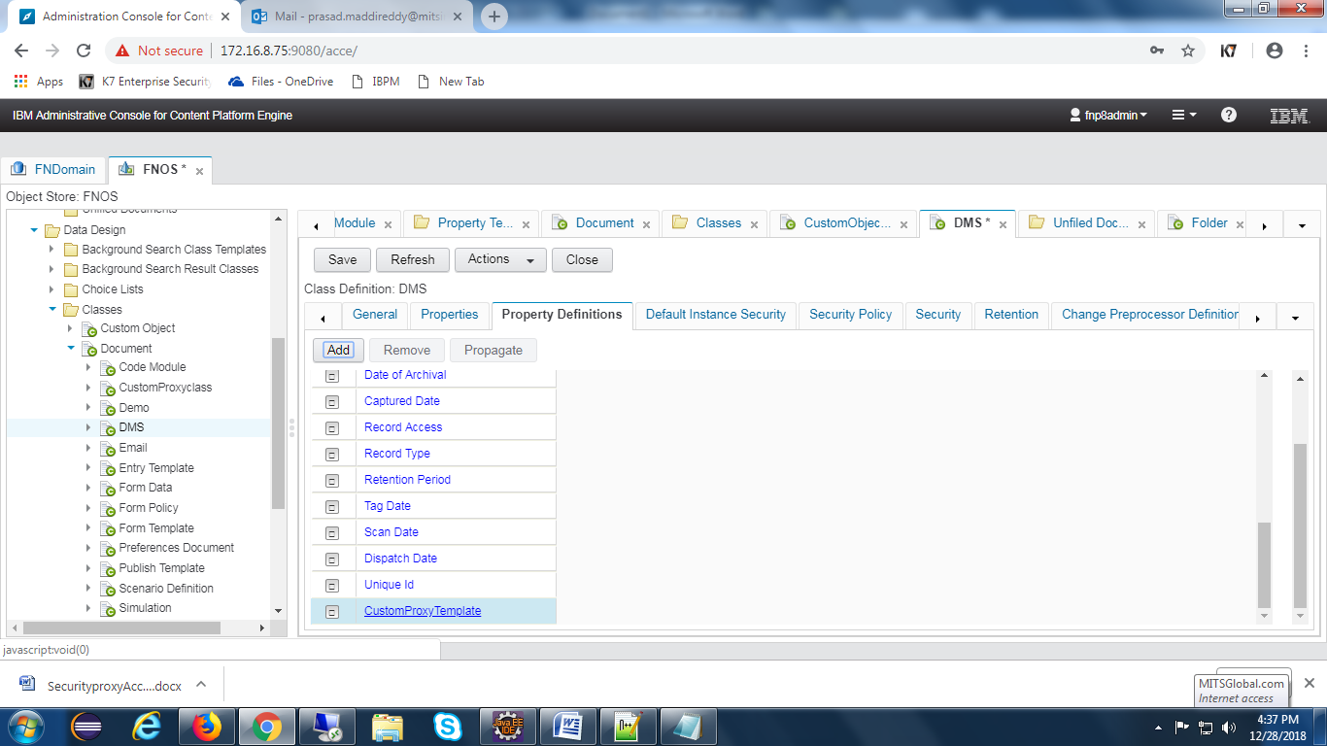

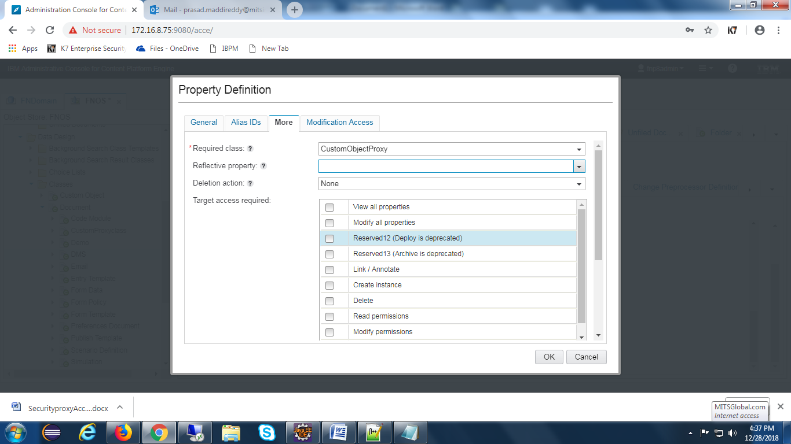

Create two proxies for document and folders

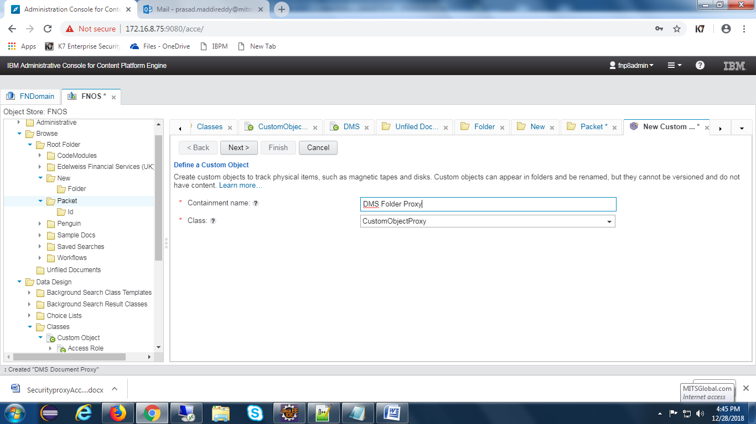

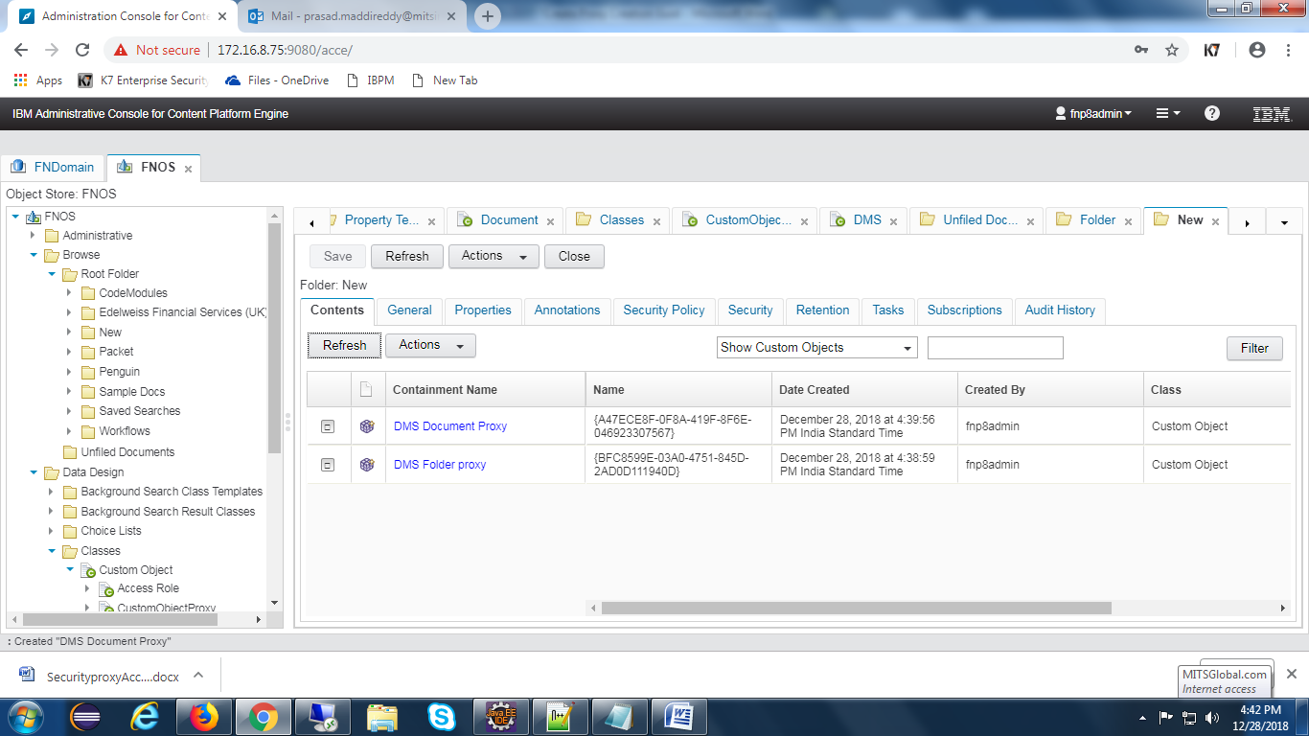

## Workflow Subscription

**Create Event action:-**

Open acce and select event actions tab to create event action.

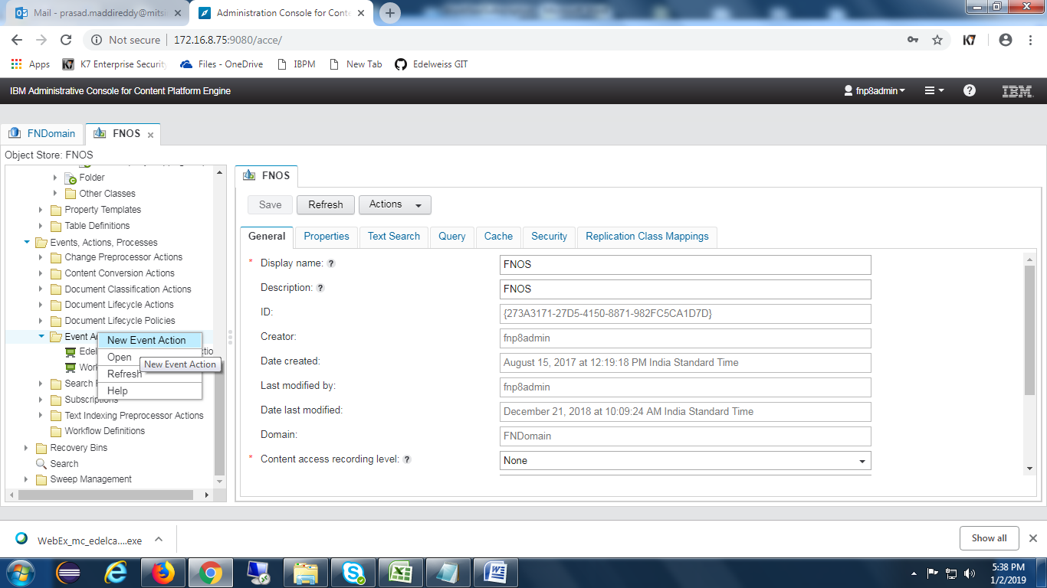

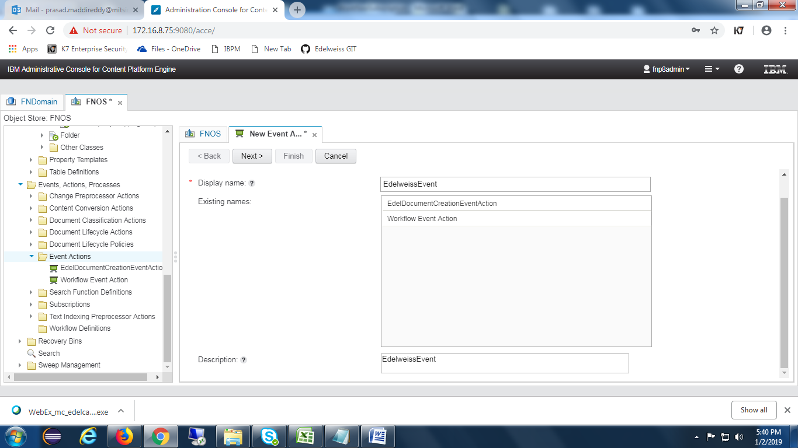

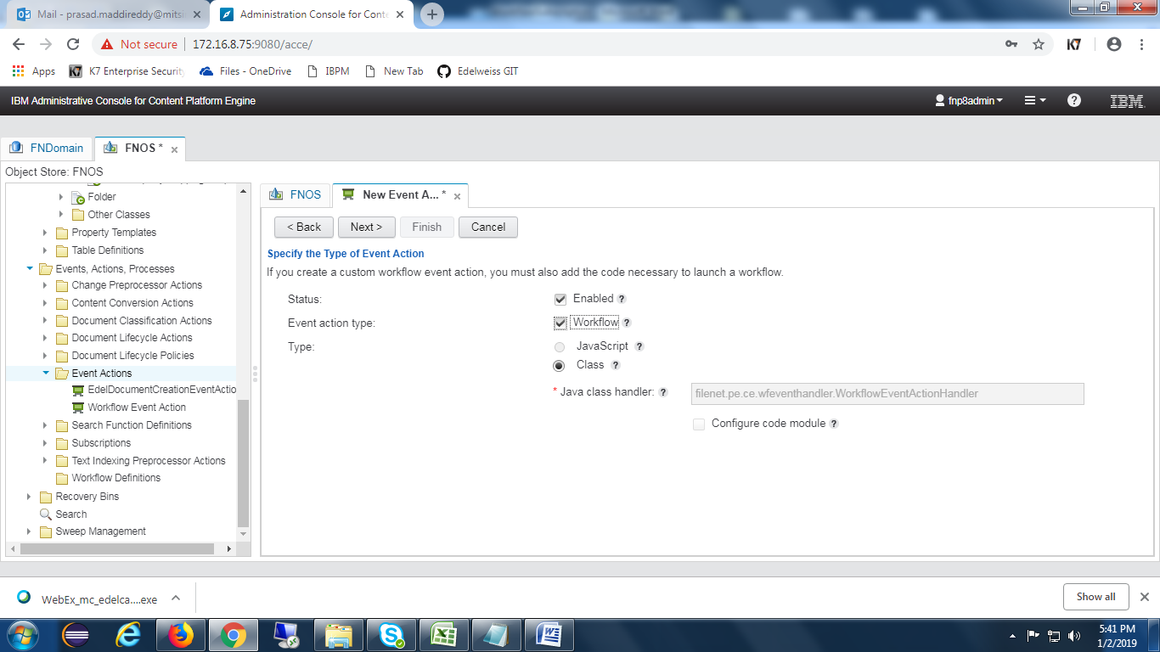

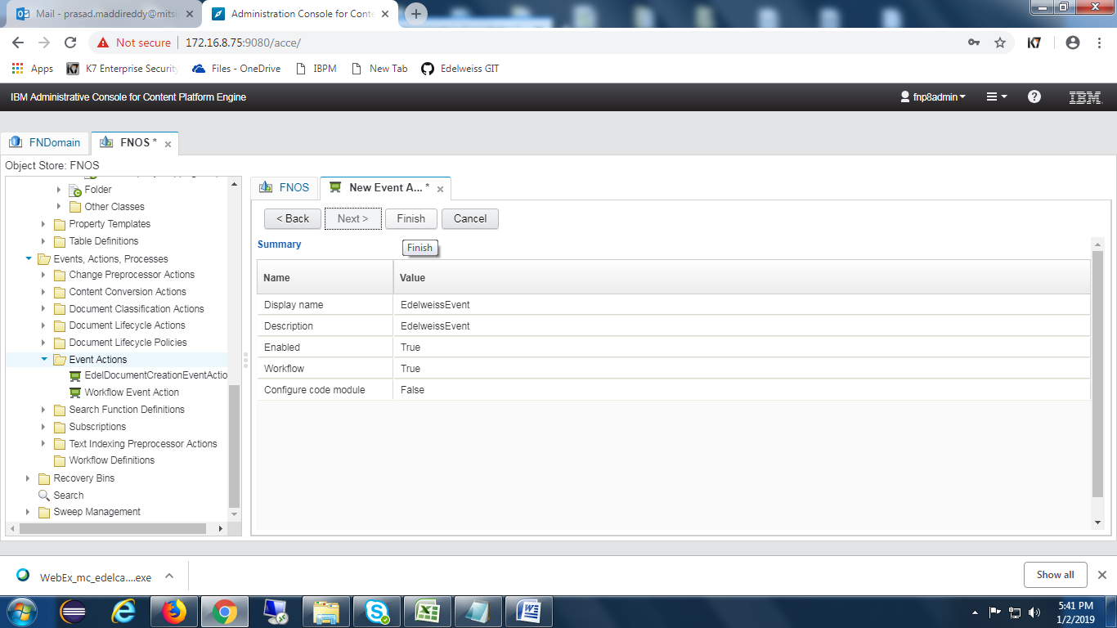

**Create Subscription:-**

Select the required class to create subscription. Once selecting the class , choose subscription button as shown in the below screen.

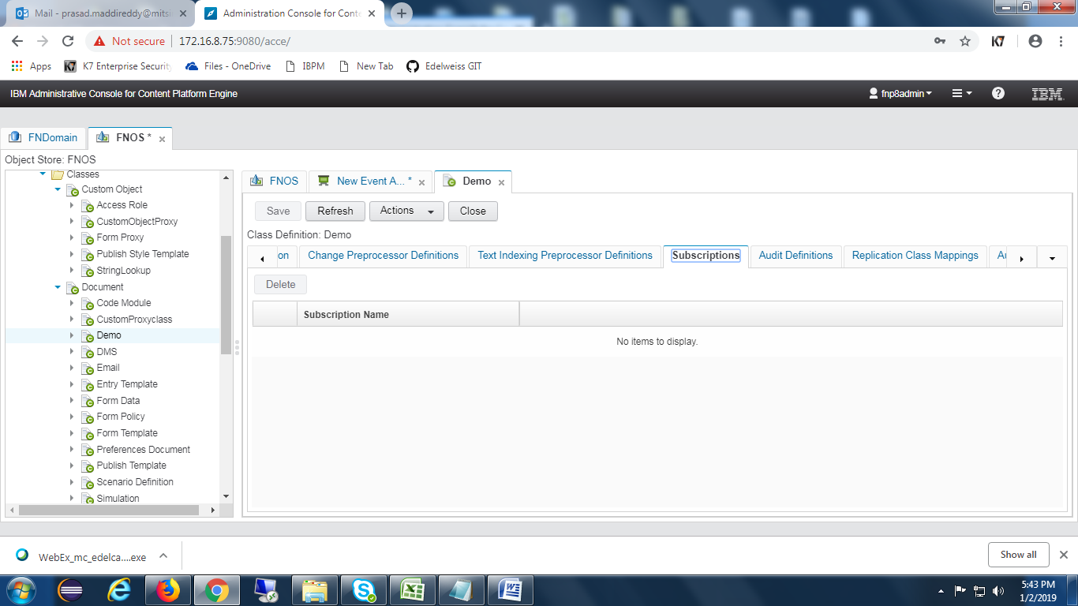

Click on **Actions** and select New subscription as below.

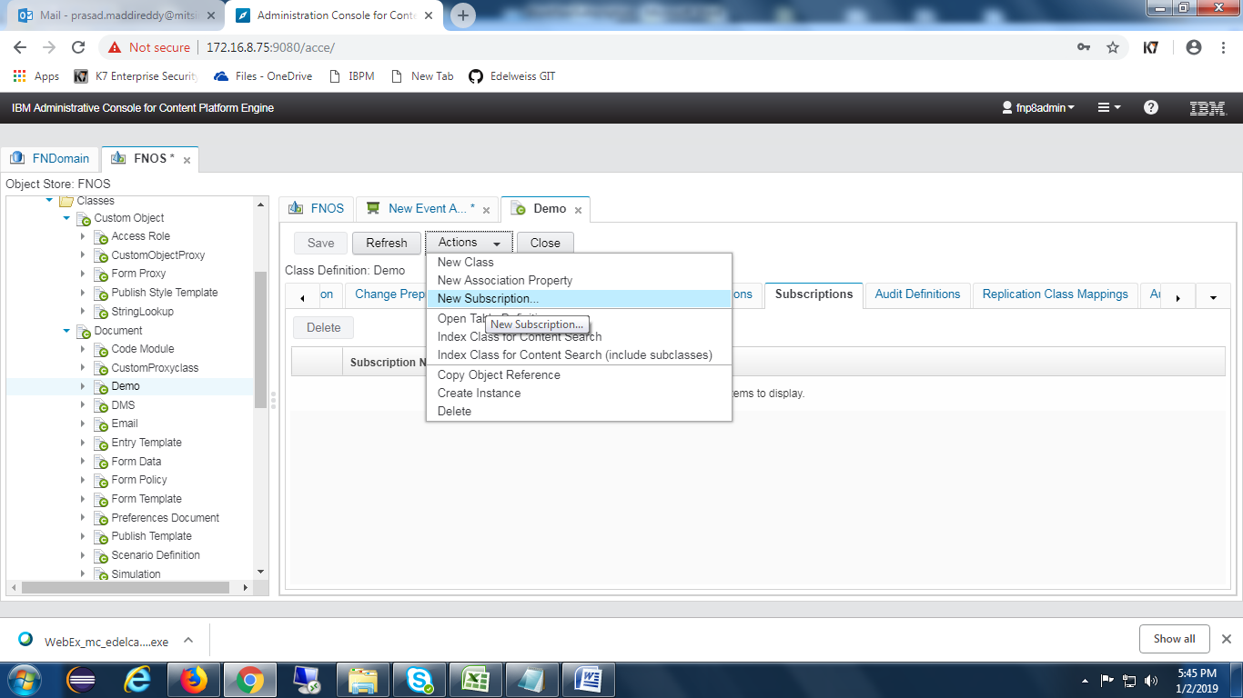

Give name for the subscription.

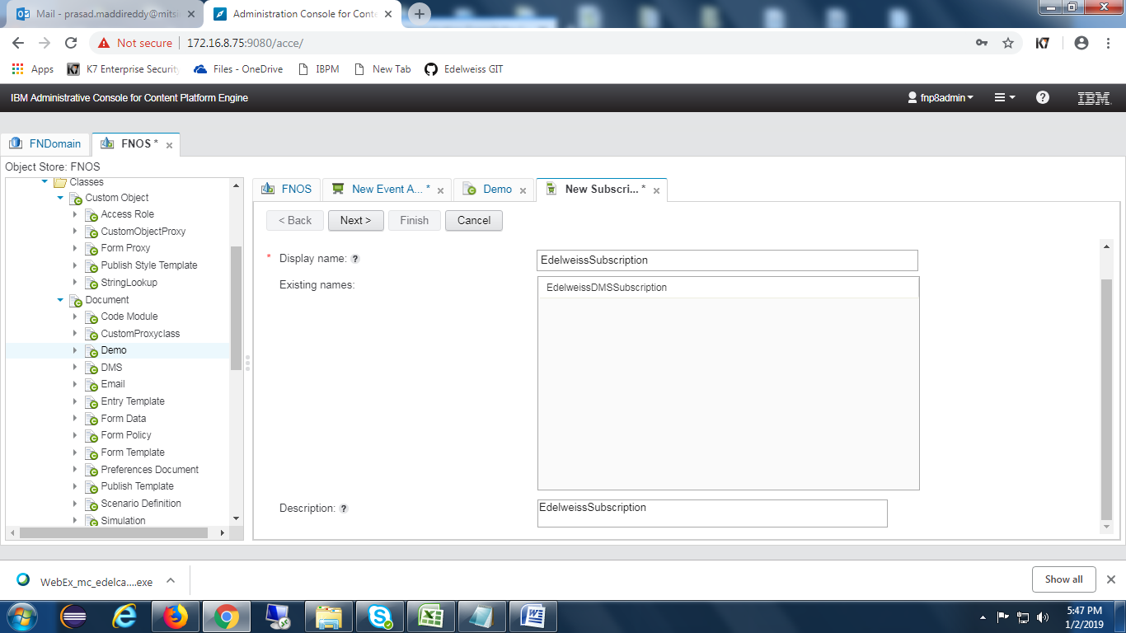

Select **Create a workflow subscription** checkbox as shown in the below screen.

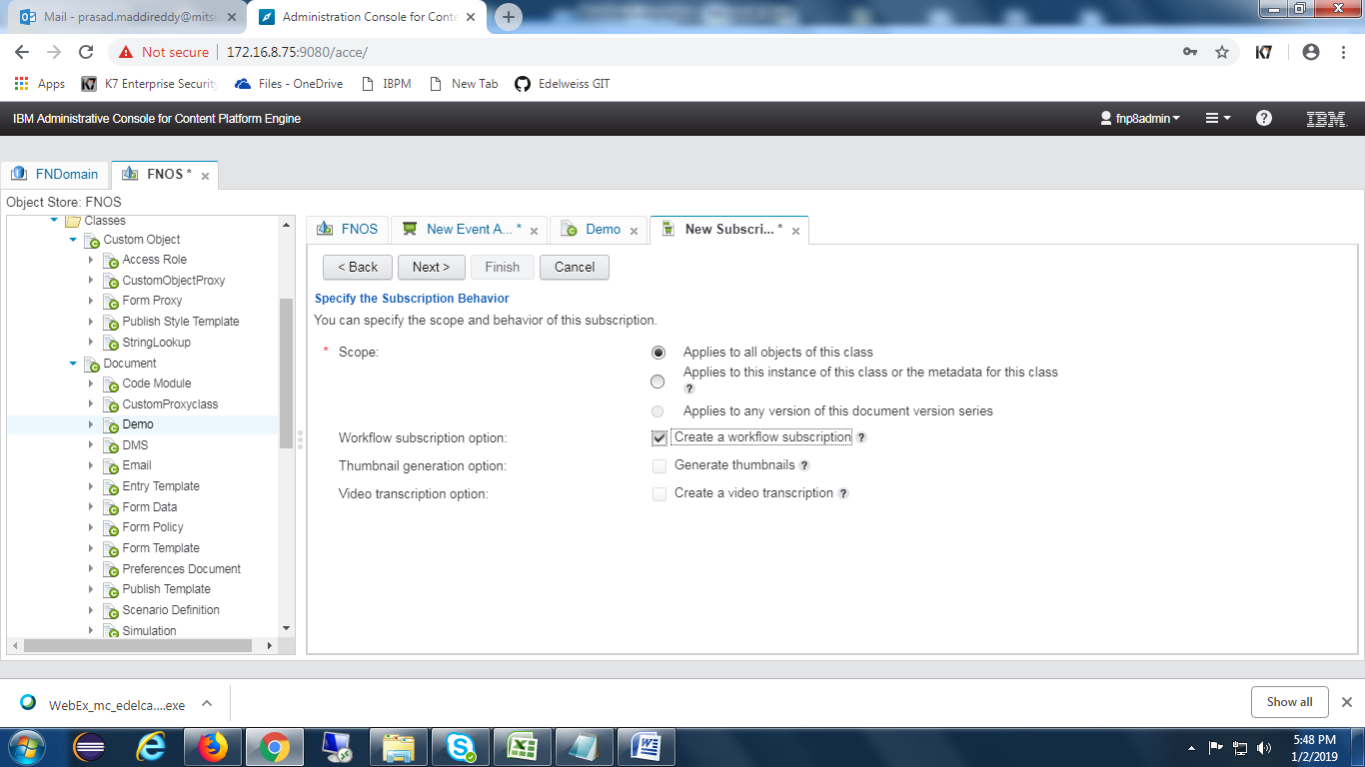

Choose appropriate **Event(Creation Event)**

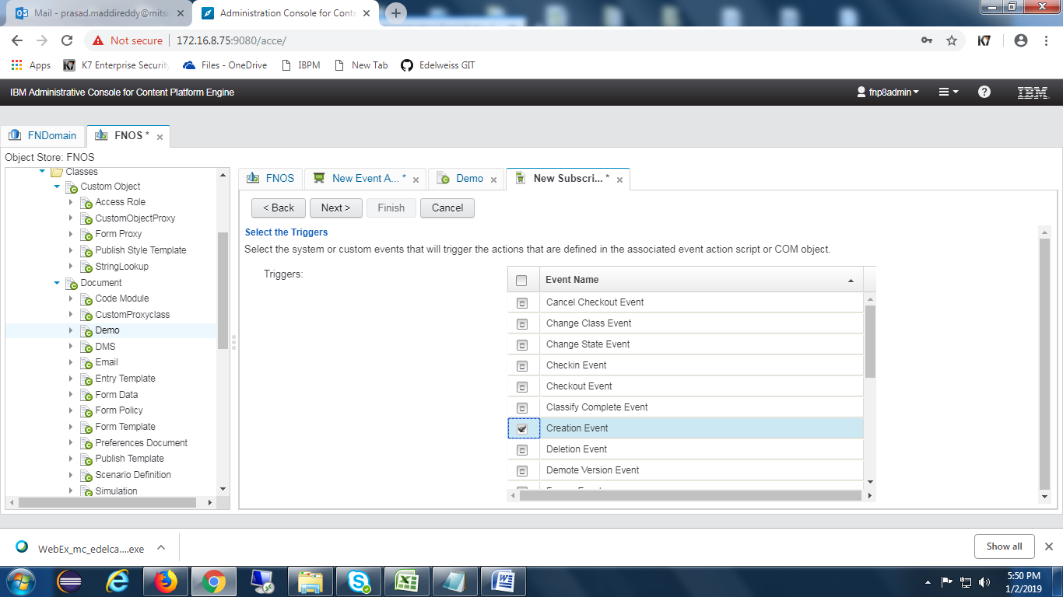

Choose the **event action** which was created earlier.

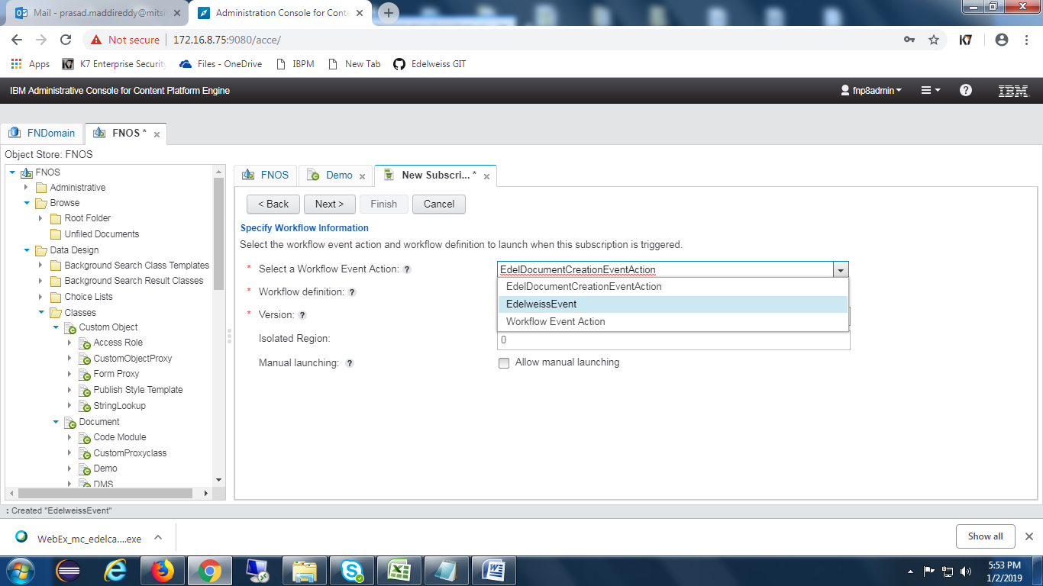

Choose the **Workflow** shown in the drop down.

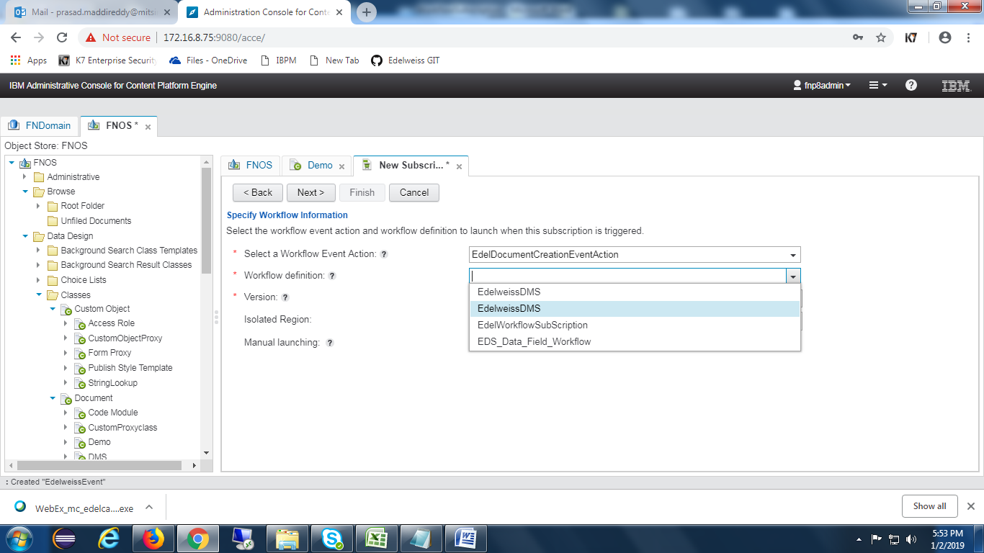

Map Workflow properties with the CE properties as below

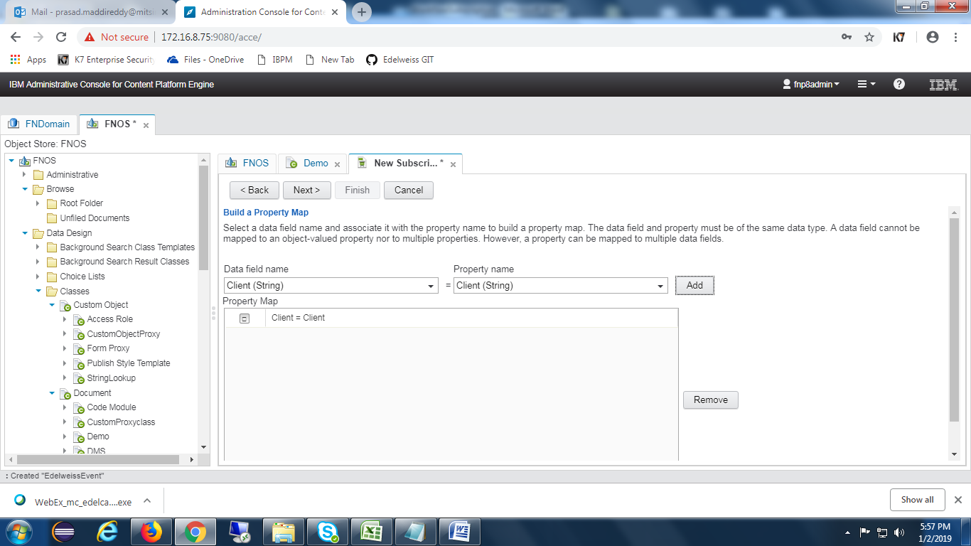

Click on **Next** button as shown in the below screen.

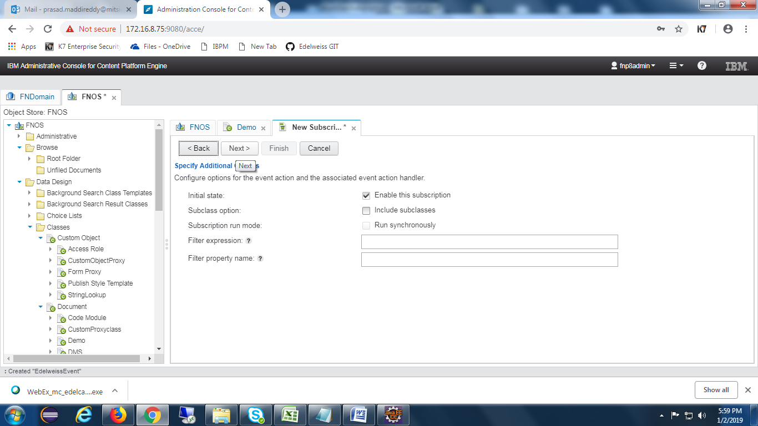

Press on **Finish** button as well.

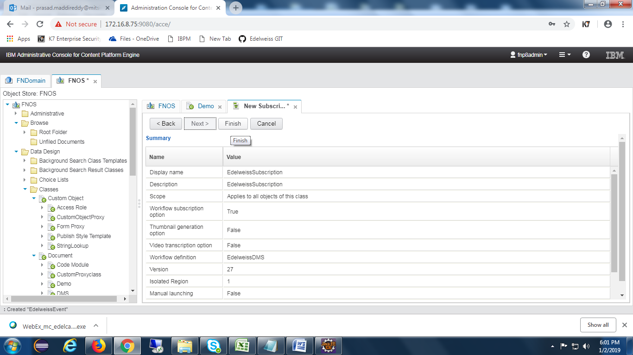

Open the subscription and Click on Configuration and add filter expression as below.

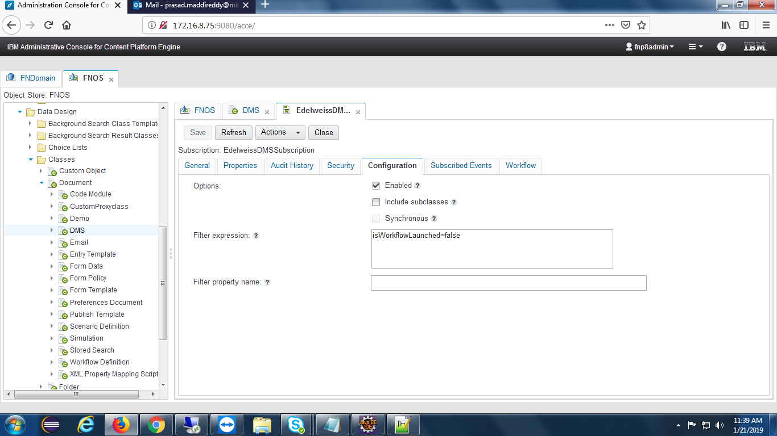

## CE Properties

Below are the symbolic names of the property templates.

I. AdditionalHashtag1(String)

II. AdditionalHashtag2(String)

III. BoxBarcode(String)

IV. CapturedDate(Date Time)

V. Client(String)

VI .CustomProxyTemplate(Object)

VII. DateofArchival(Date Time)

VIII. DispatchDate(Date Time)

IX. DMPartner(String)

X. DocumentType(String)

XI. Entity(String)

XII. FileBarcode(String)

XIII. isWorkflowLaunched(Boolean)

XIV. LOB(String)

XV. Product(String)

XVI. RecordAccess(String)

XVII. RecordClassification(String)

XVIII. RecordName(String)

XIX. RecordType(String)

XX. RetentionPeriod(String)

XXI. SBU(String)

XXII. ScanDate(Date Time)

XXIII. Stage(String)

XXIV. Status(String)

XXV. TagDate(Date Time)

XXVI. UniqueId(String)

## Desktop Creation

Open navigator and select **Open administration view** feature. Select **new desktop** button and it will show below screen.

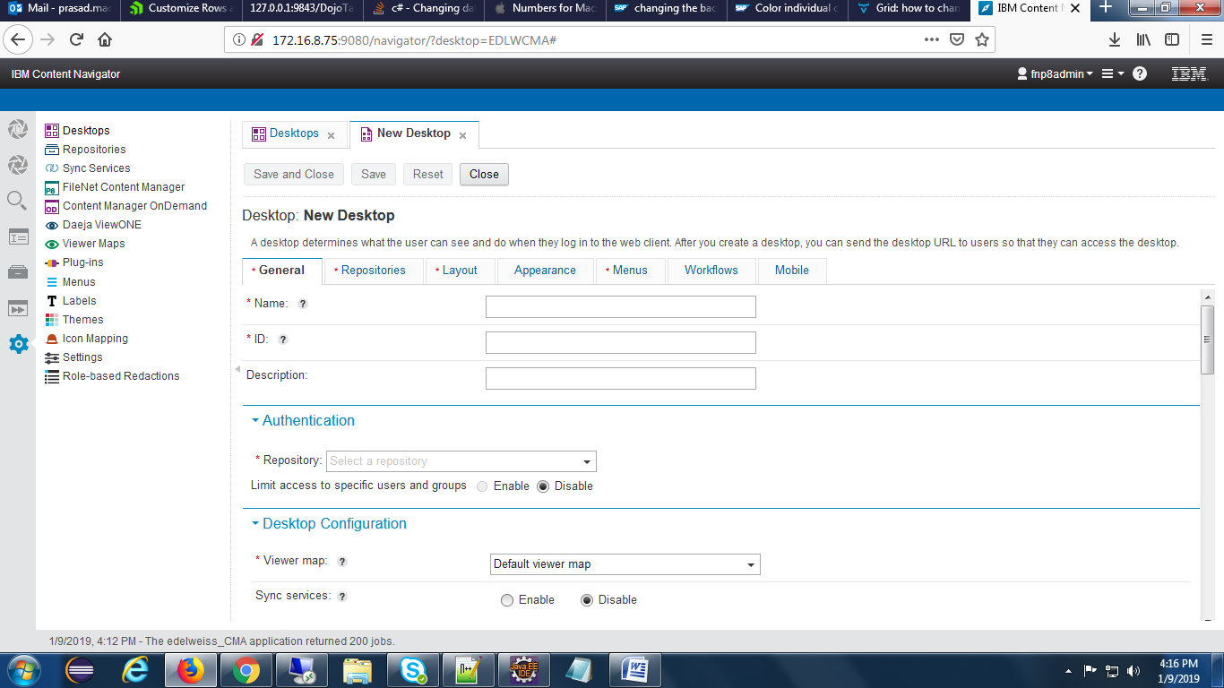

Provide desktop Name and Id and Description and select appropriate repository in the drop down of repository.

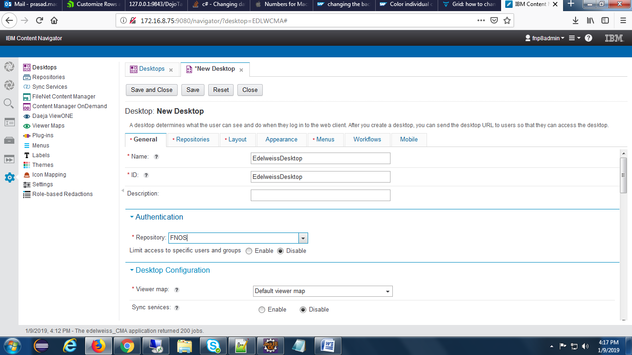

select repositories tab and choose the repository as below.

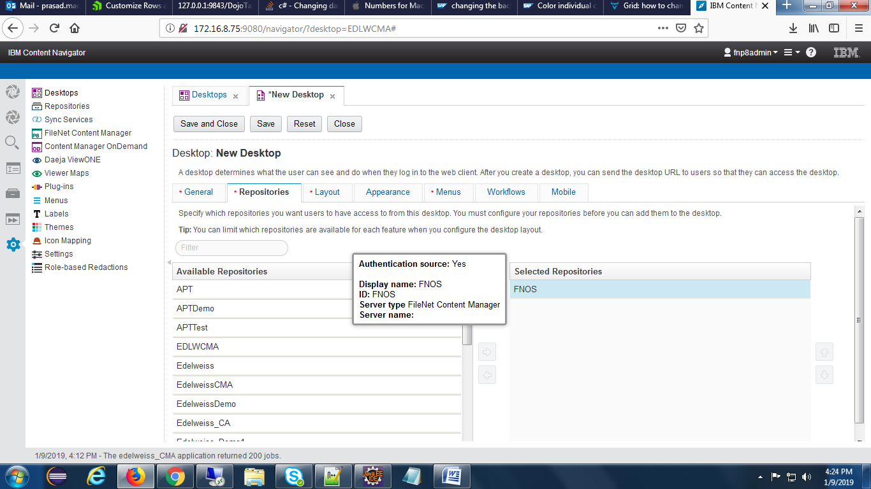

## Reports

**2.8.1** Reports please configure the below steps

Workflow Data Fields add ‘Processcompletedate’.

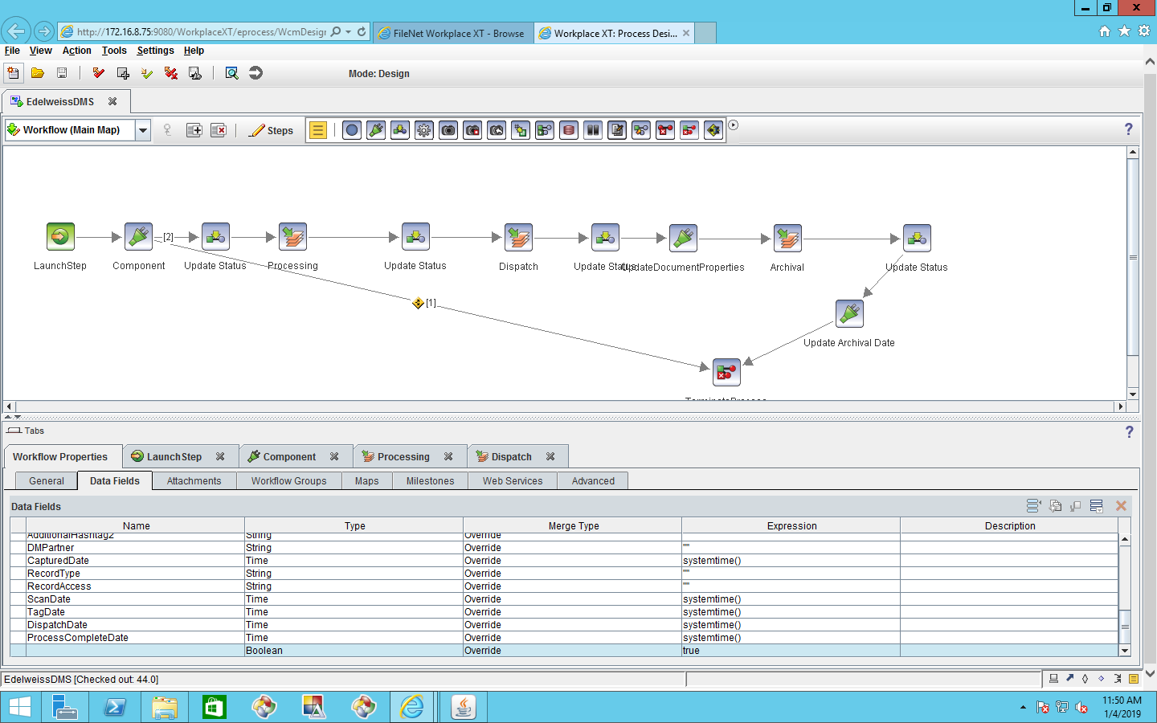

2.8.2 Above create field add to “Processing” step Click on “Assignments” and click on “AfterCompletion”.

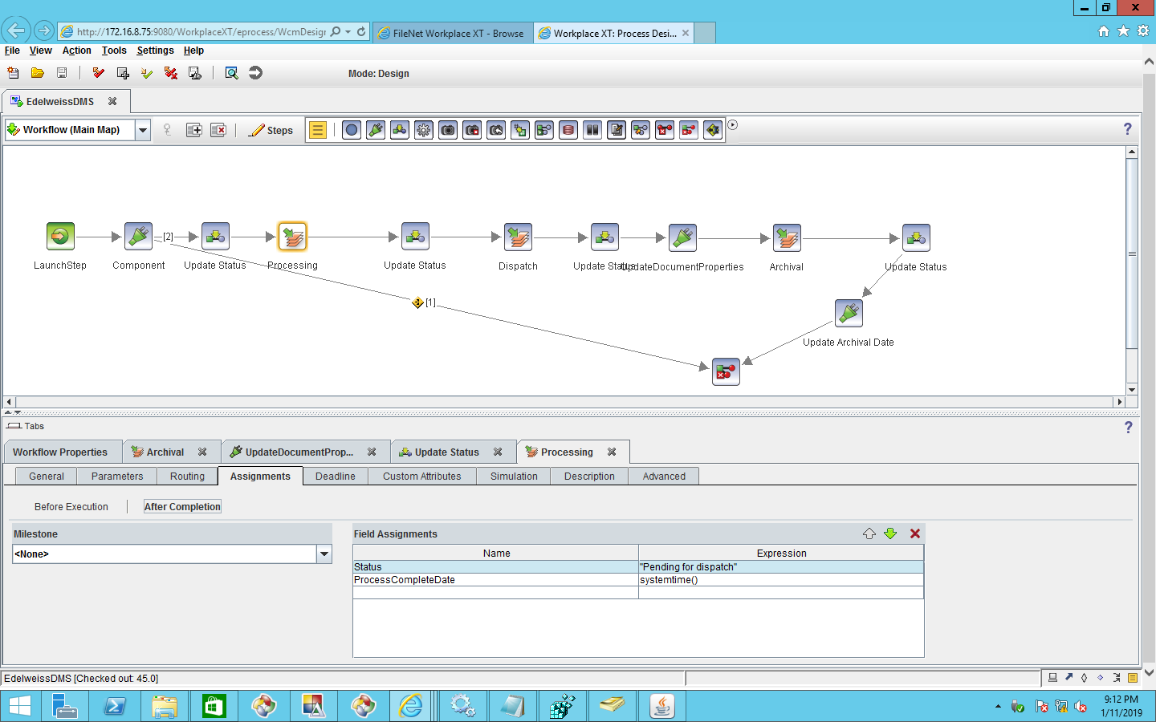

2.8.3 In “ACCE” need to create ‘[ProcessCompleteDate](javascript:void(0))’ Property and update the workflow version and subscription, in fields with workflow fields([ProcessCompleteDate](javascript:void(0))=[ProcessCompleteDate](javascript:void(0))’) also TagDate,ScanDate need to add subscription for reports.

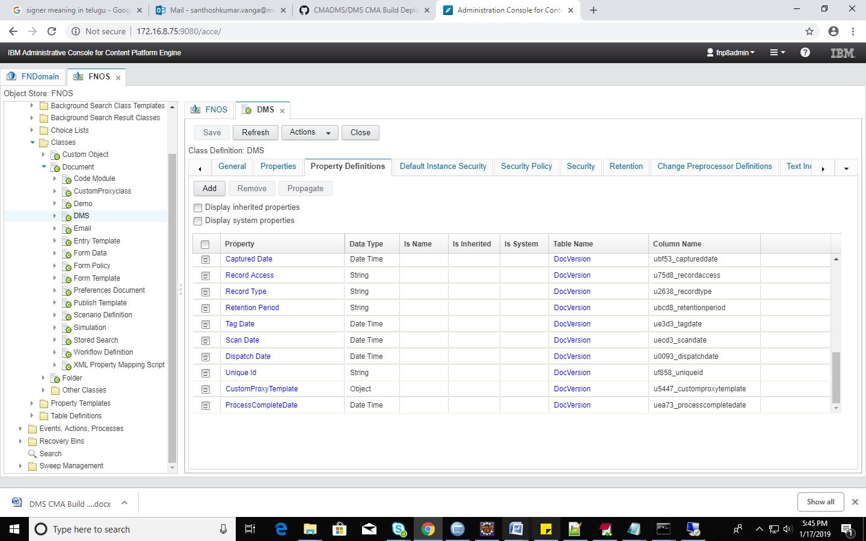

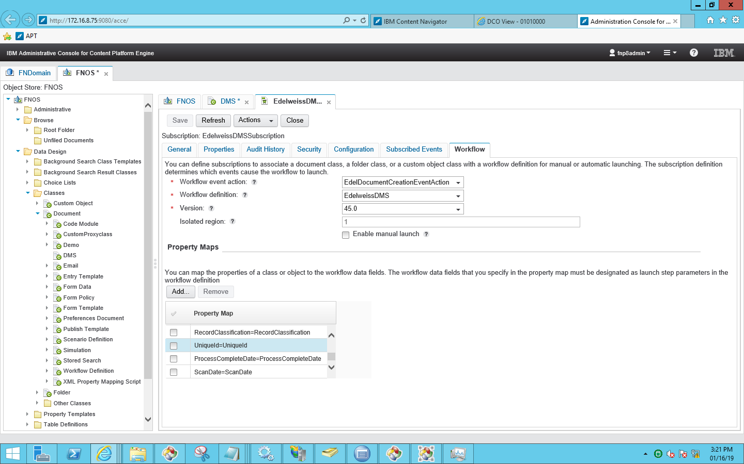

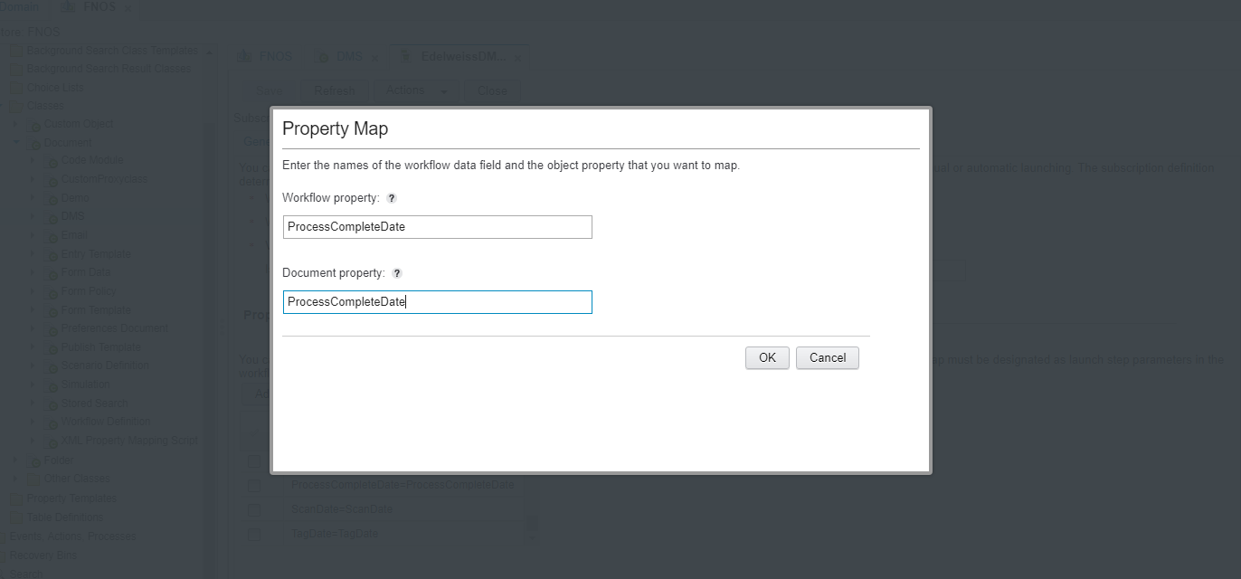



For “event log query “need to expose the fields in “DefaultEventlog “

Open “DefaultEventLog” and expose below fields.

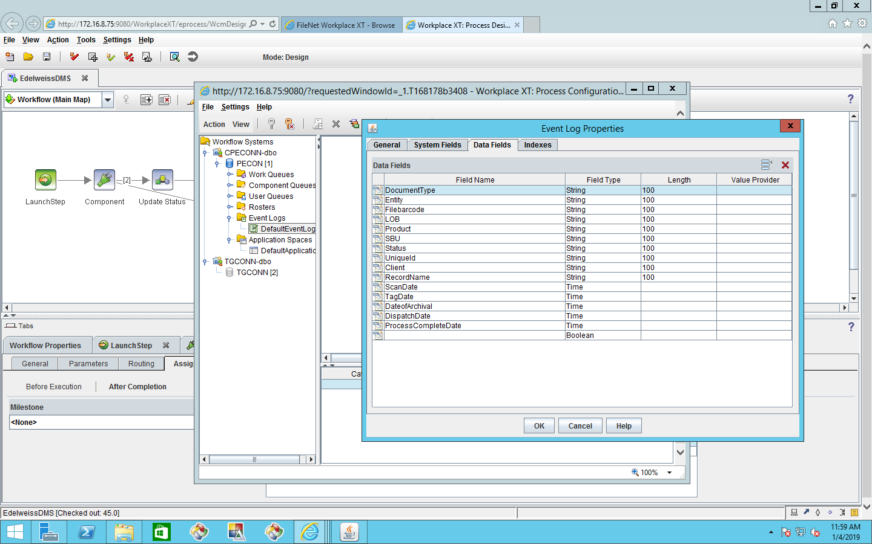

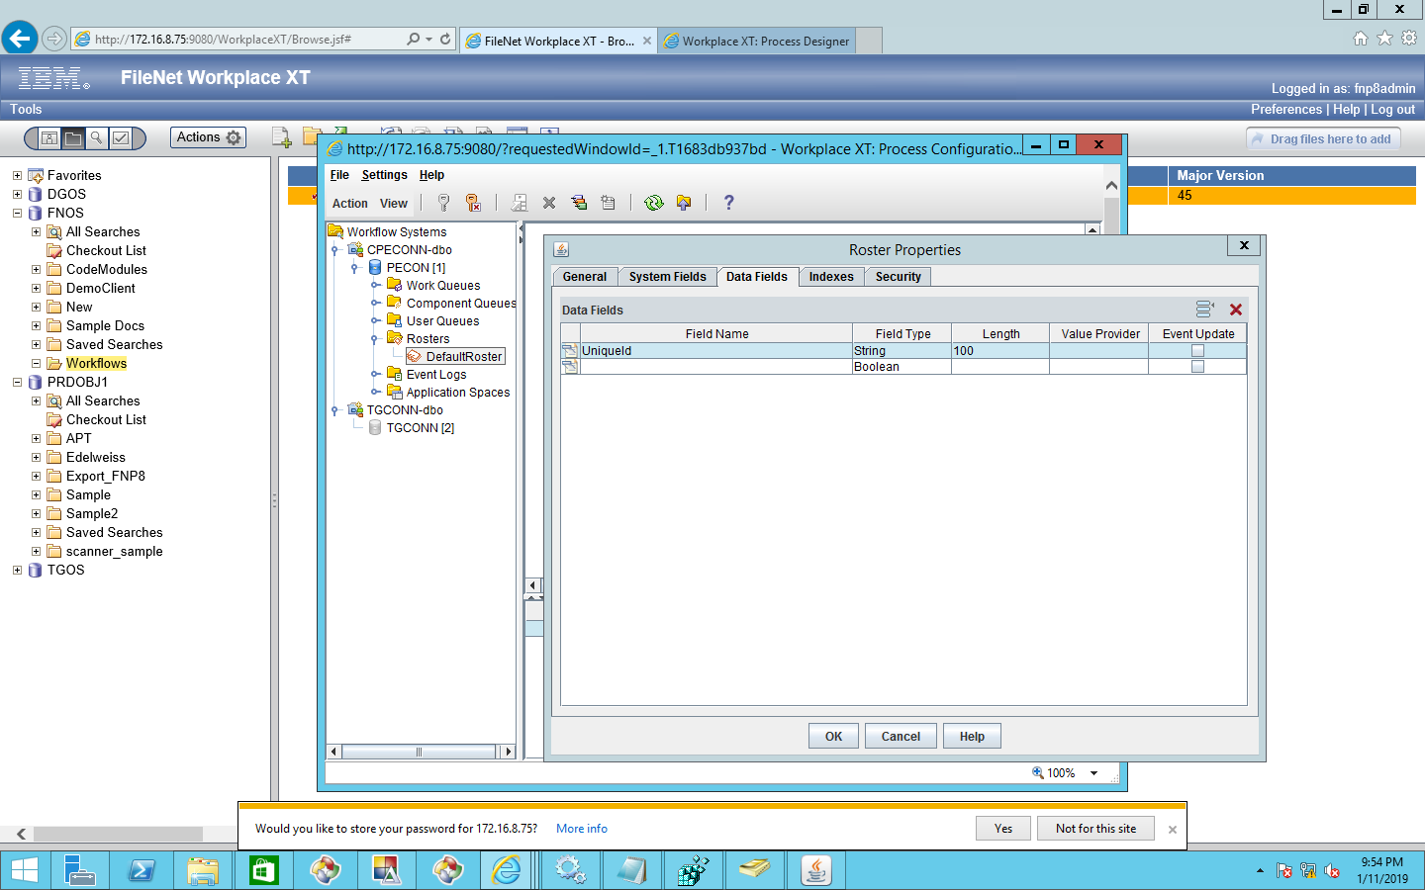

Reports utility should be placed inside of the **CMA DMS workflow Report** folder.

C:\CMA DMS workflow Report\Report Utility

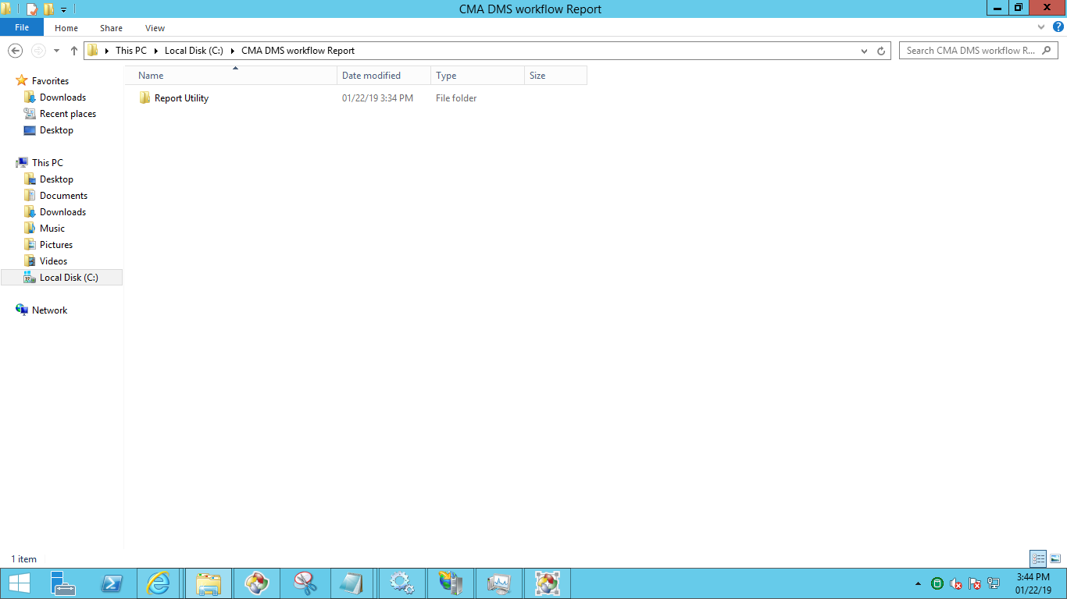

Propertyfile should be placed in below path

C:\CMA DMS workflow Report\Report Utility\UpdateValues.properties

Reports utility Log file will get generated in the below path

C:\CMA DMS workflow Report\Report Utility\Logs\DMSReportLogger.log

## CR'S

**1)Change Unique Id to Packet ID**

* Create Property template in ACCE with name of PacketID

Go to ACCE and select Property templates folder, create new one as shown in the below sceen

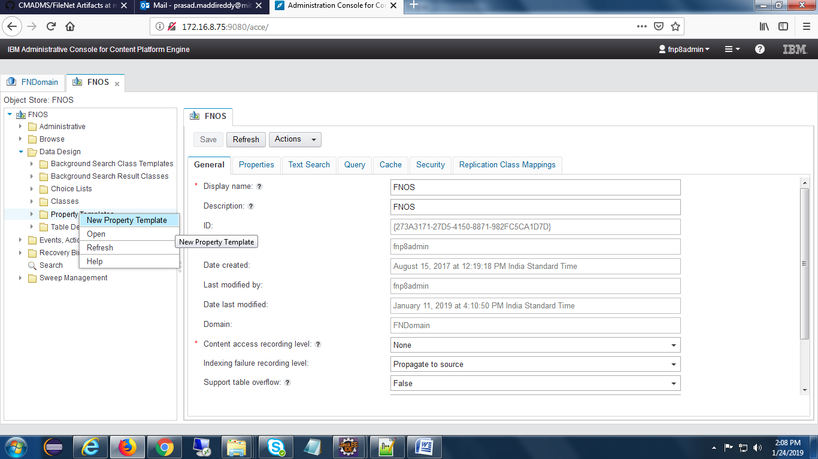

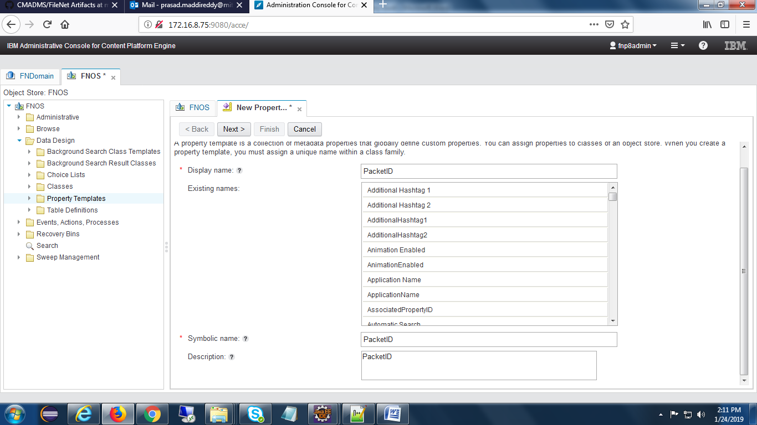

click on next and finish buttons.

* Add PacketID property to DMS class.

Open ACCE and add the PacketID property to DMS class as shown in the below screen,

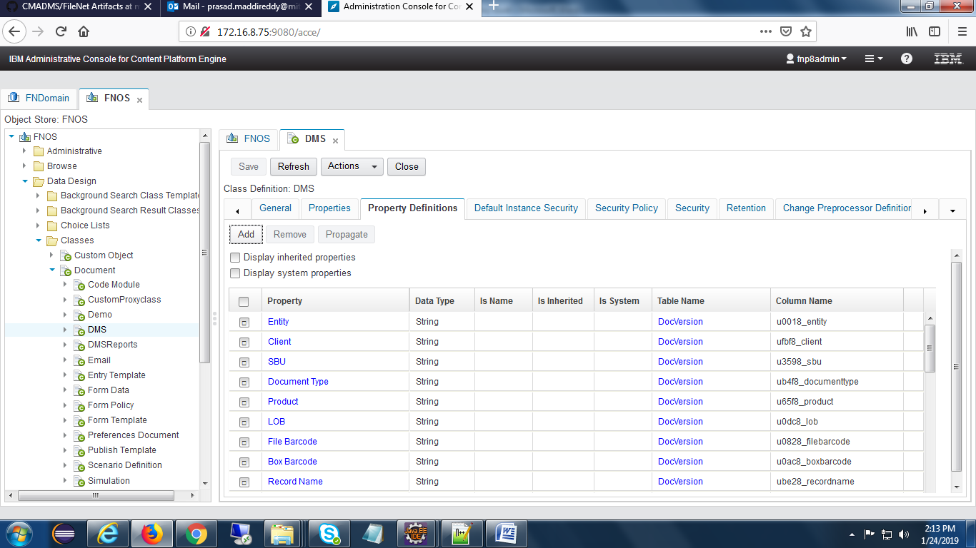

* Add PacketID property at WorkQueue

Open WorkplaceXT and go to process configuration console , select the work queue as below

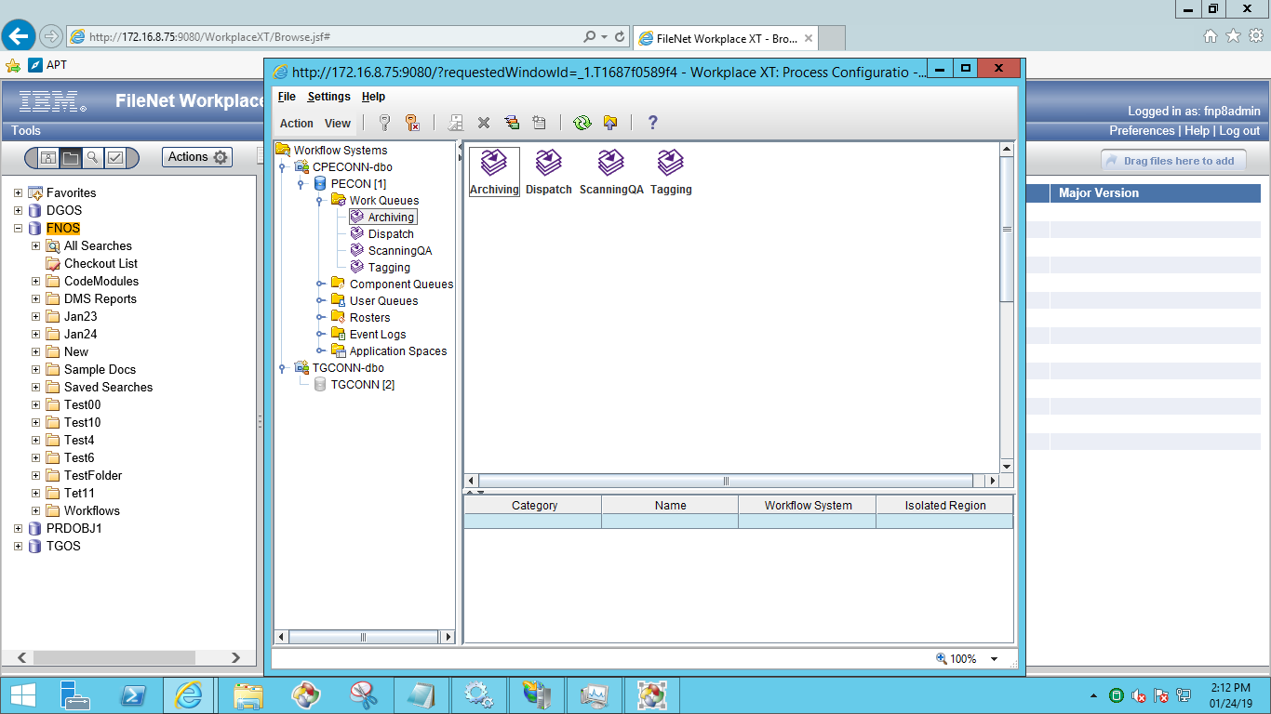

Click on work queue, open properties tab and add Packet ID field as below

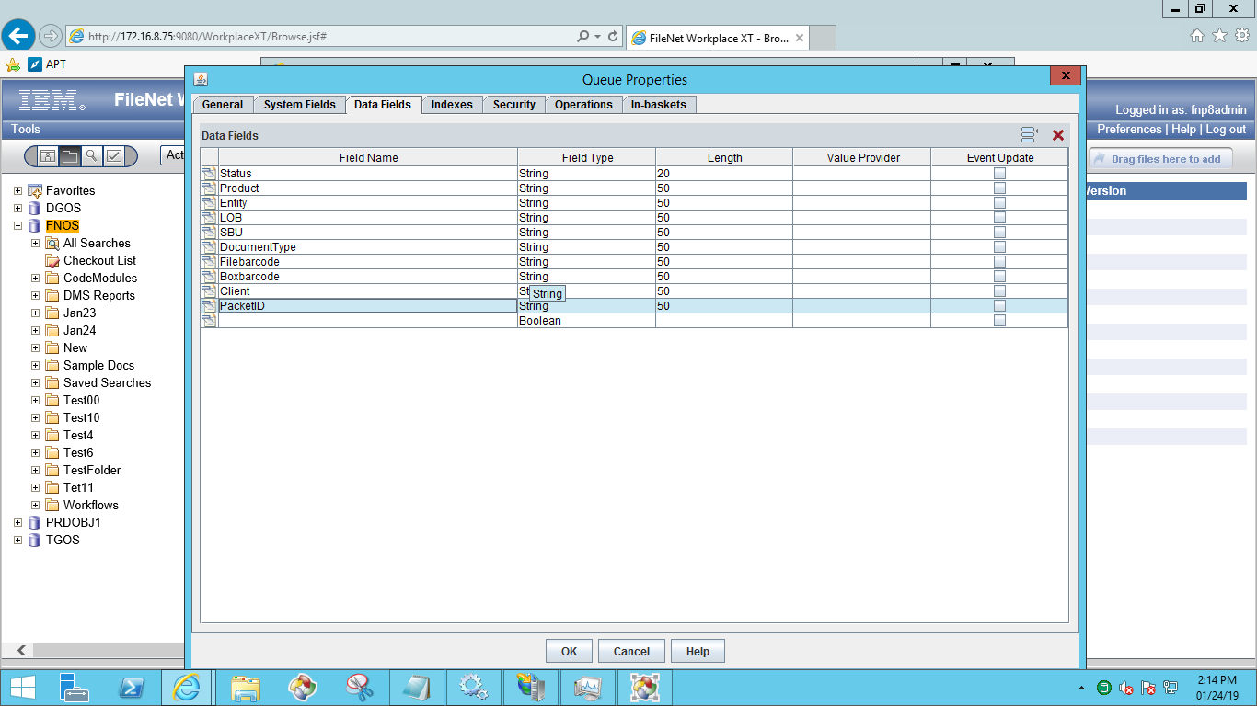

Go to inbasket tab and add PacketID field as shown in the below screen

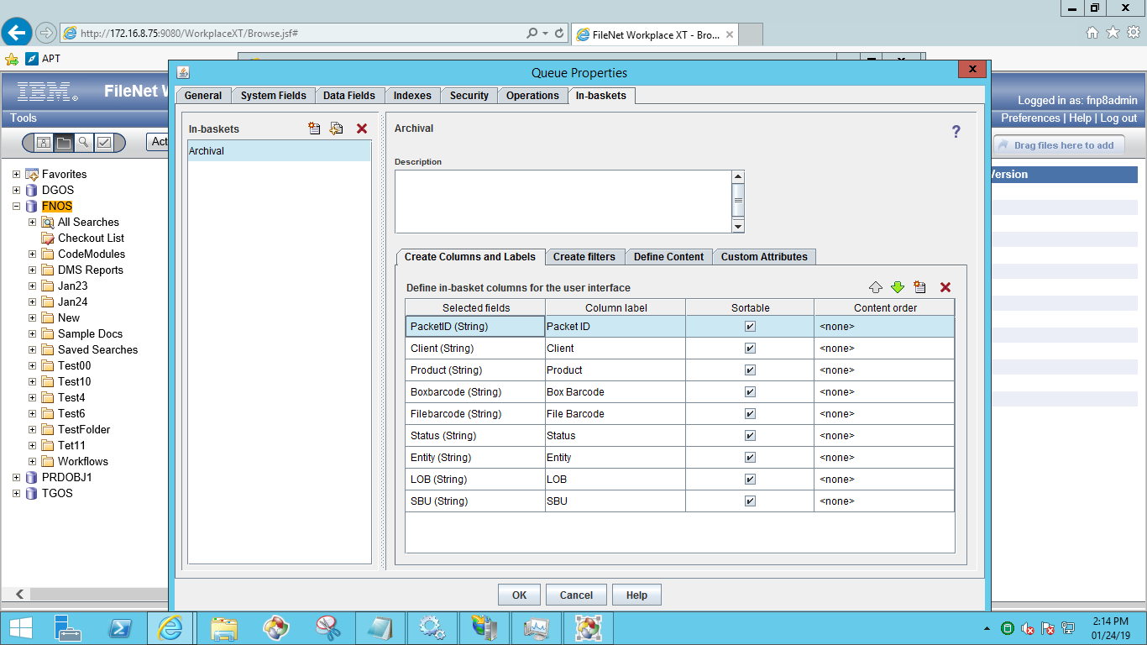

Note: Add PacketID for both work queues(ScanningQA,Archiving)

* Add in repository

Open Administration view feature and select repository then click on edit button.

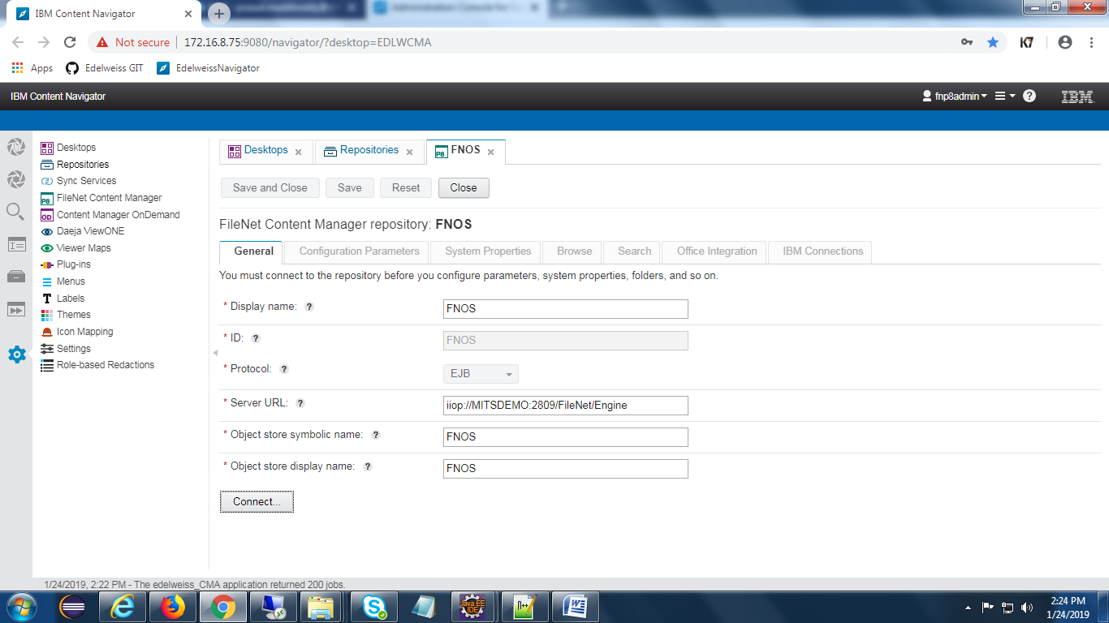

Connect to repository and select Brows tab, then add the PacketID property as shown in the below screen

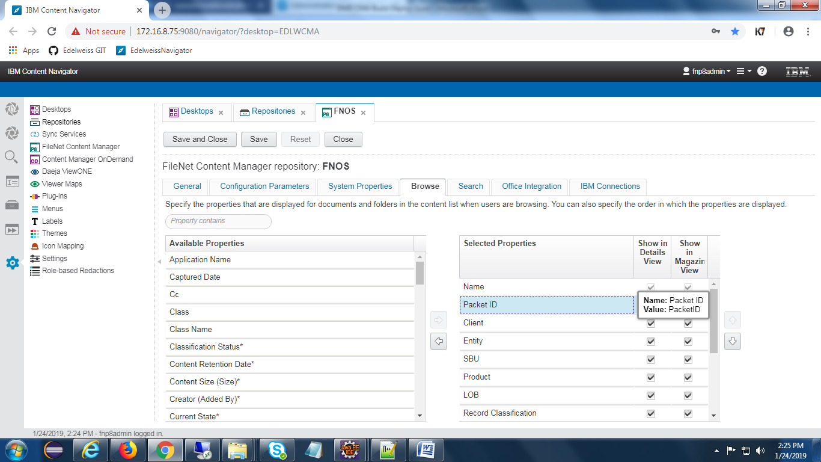

* Add in Workflow

Open Workflow and add PacketID field as below

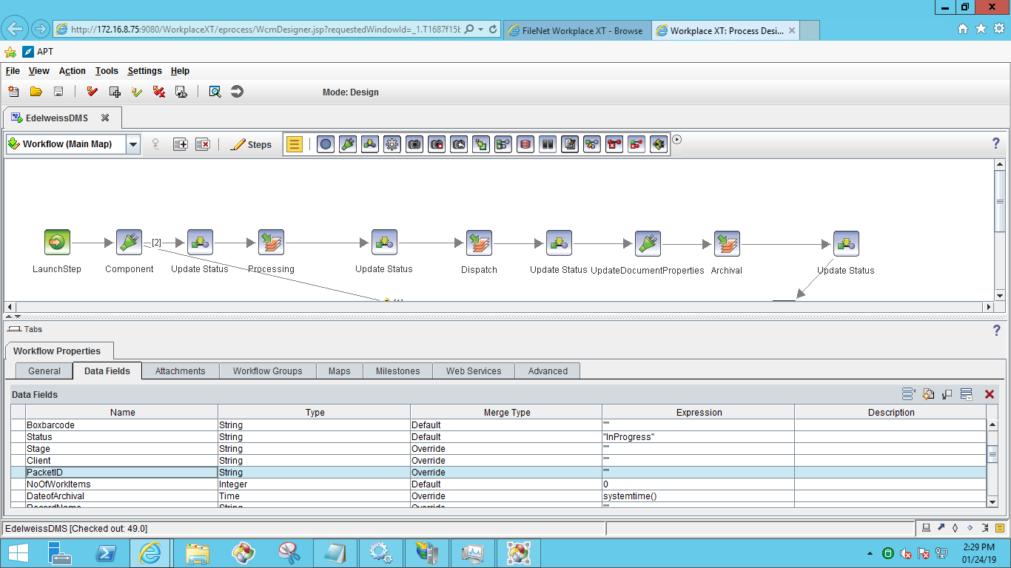

Click on Launch step and select assignments and configure PacketID as shown in the below screen

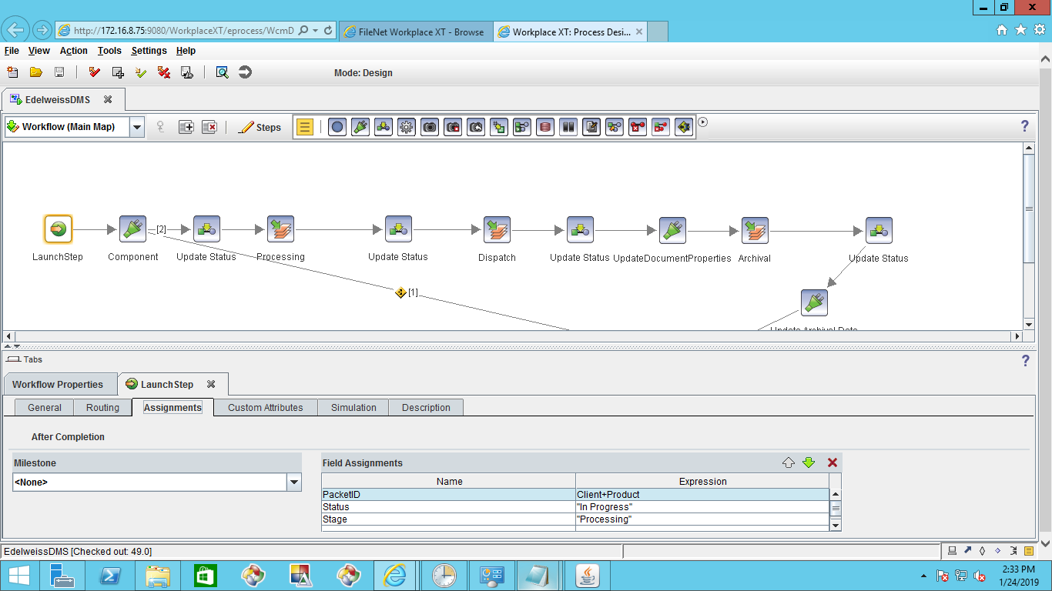

Select the component in the workflow and configure the PacketID as below

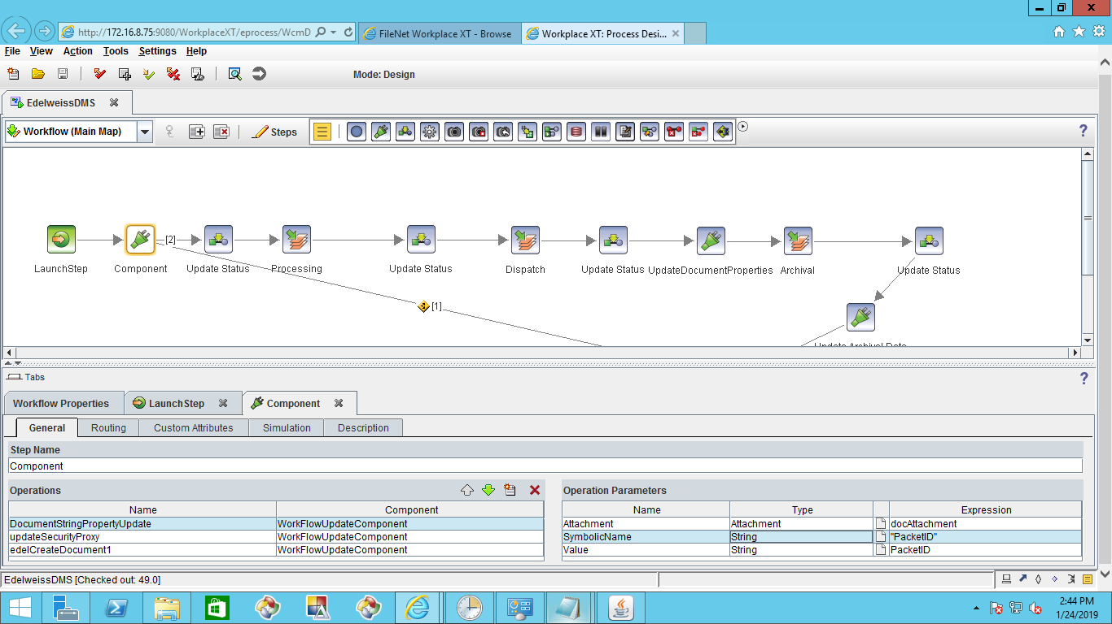

Include PacketID in all the steps(Processing,Dispatch,Archival)

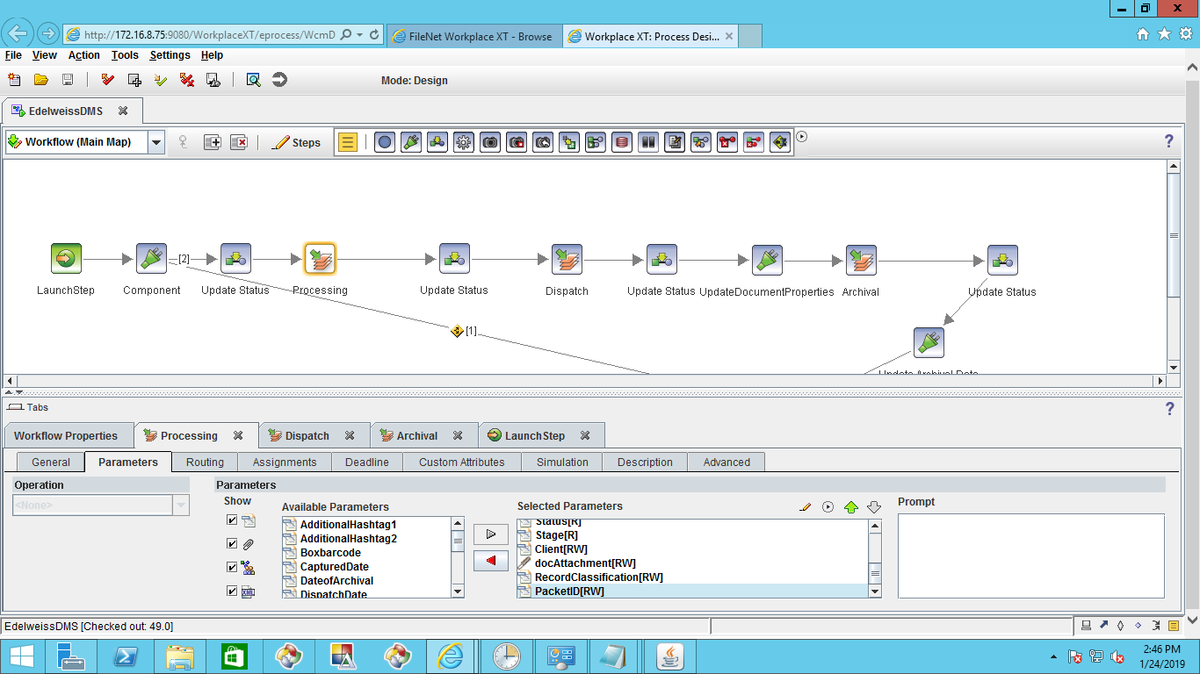

* Add at subscription, map CE property with workflow property.

Open ACCE and select DMS class and open the subscription to map the PacketID as below,

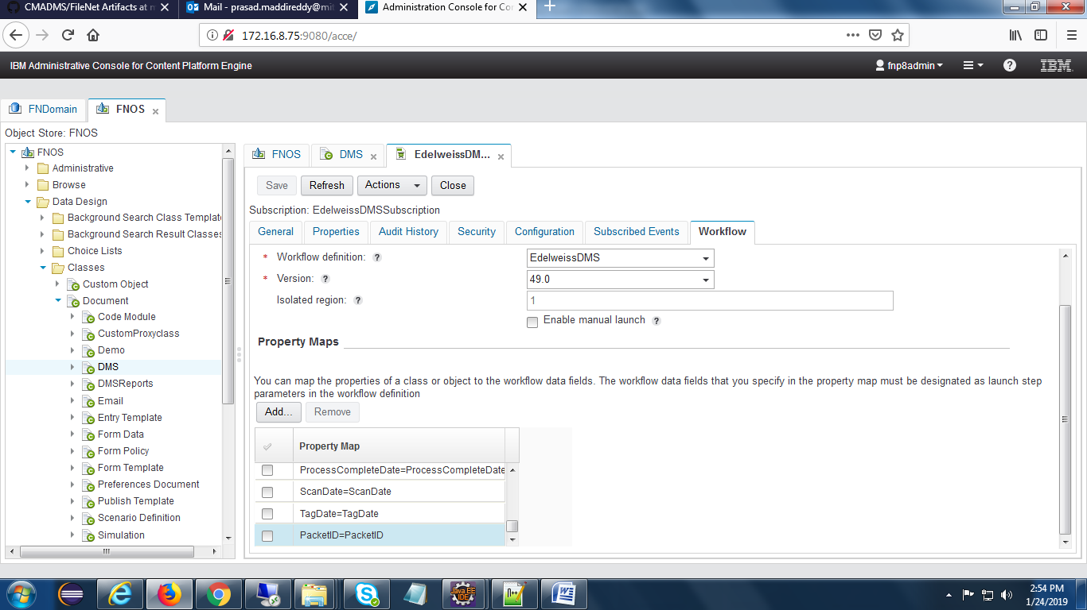

* Add Packet ID property at roaster level.

Open WorkplaceXT and go to roaster to add PacketID as shown in the below screen.

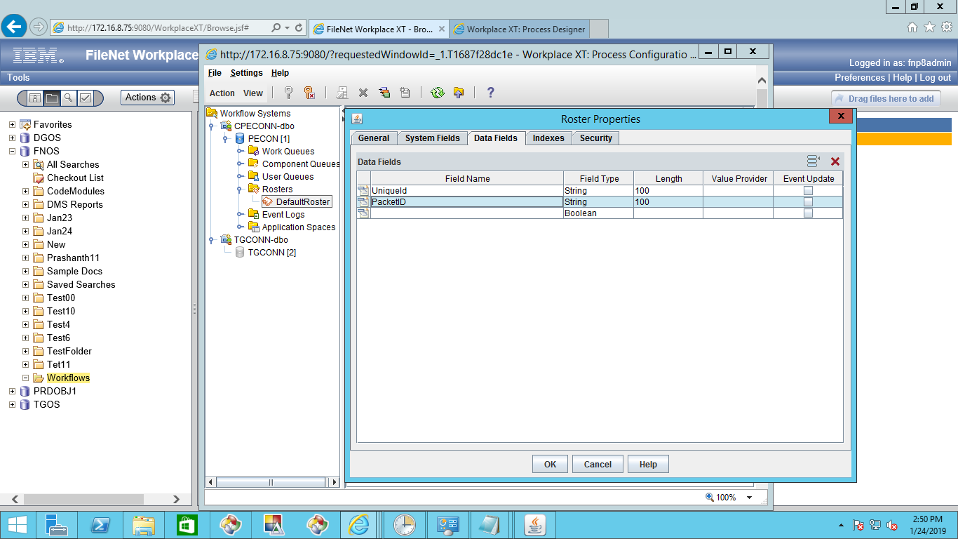

* Add the PacketID property at search template.

Open Navigator and choose DMS search template and click on edit.

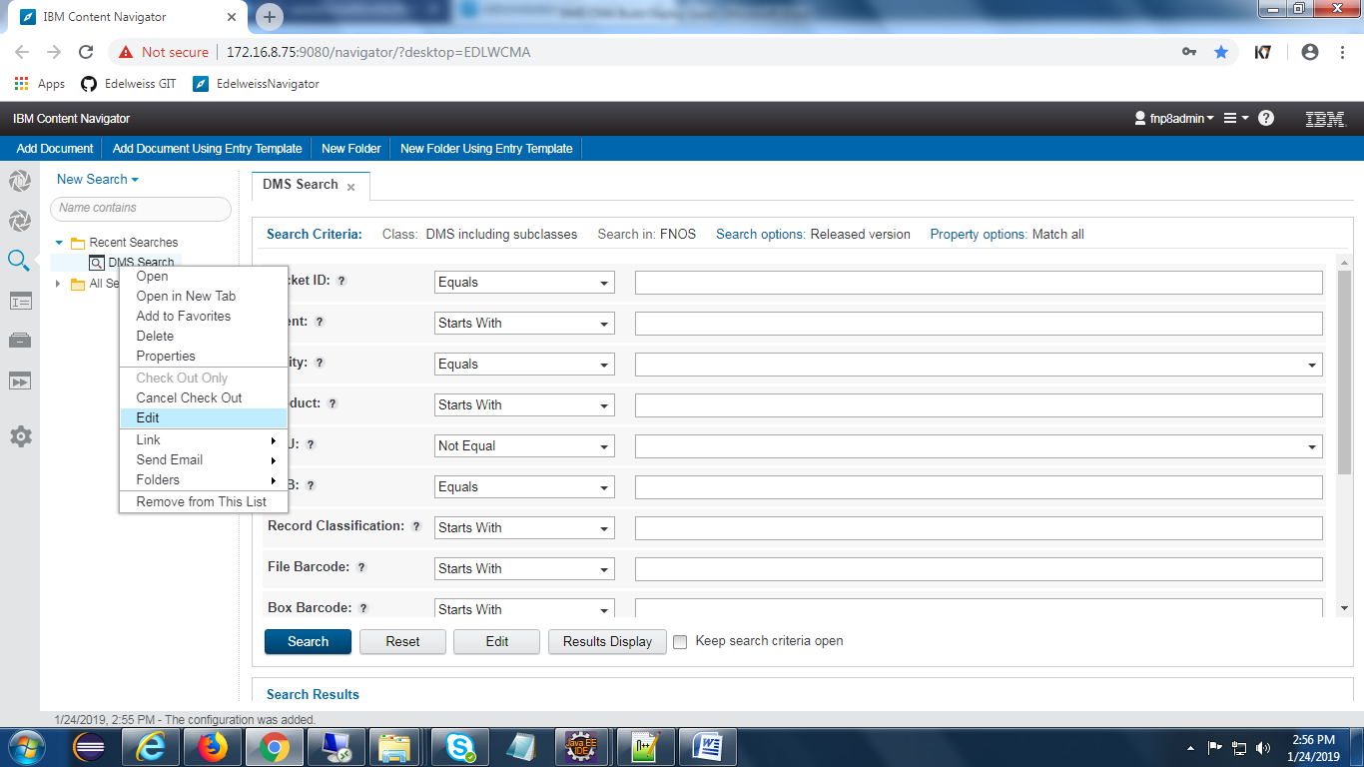

Add PacketID property as shown in the below screen

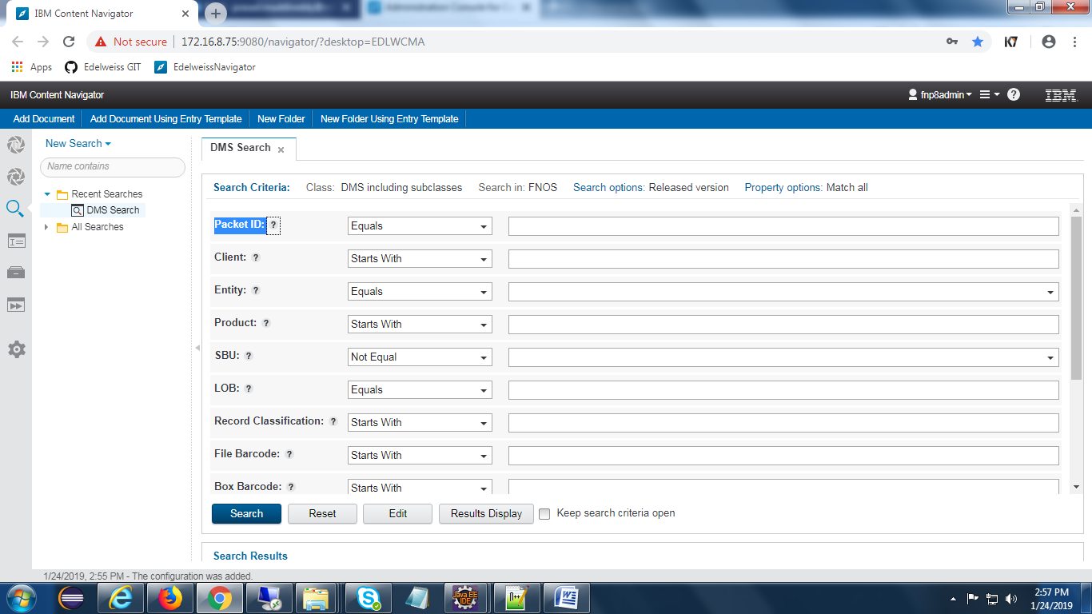

**Reports Changes :**

Need to expose field ‘PacketID’ with fieldType ‘String’ and commit the changes in ‘DefaultEventLog’

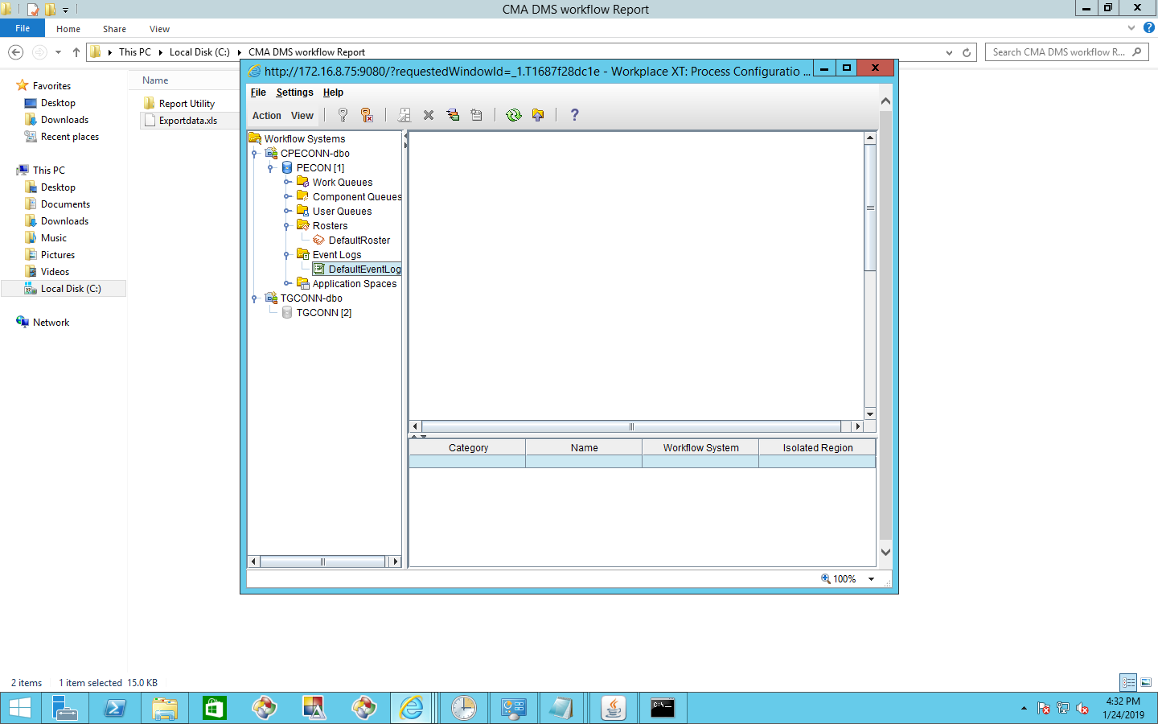

Expose the field ‘PacketID’ as shown in the below screen.

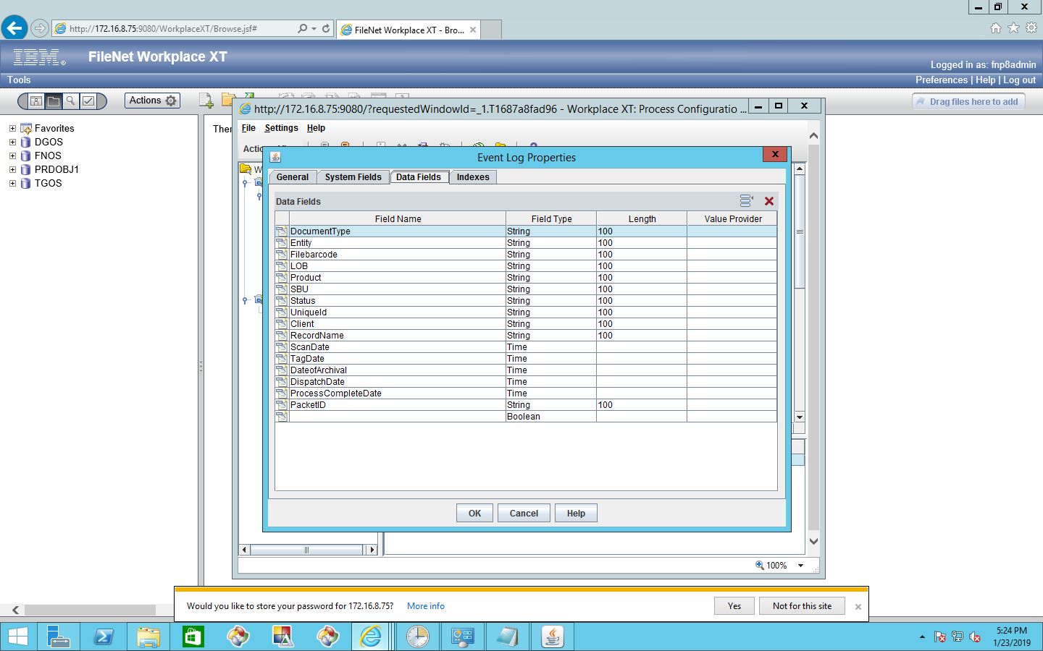

Change property file with -----🡪 UniqueId=PacketID

**Beautification in excel report:-**

We made some beautification in excel report so need to deploy the new Jar file.

**Note:-Any Configuration issues in while changes in jar file and property file please backup the jar file and .property file.**

**Navigator Plug-in jar Deployments:-**

**2) Add numbers in workflow text labels according to sequence of the field required-**

**3)Remove extra buttons “Save” and “Move –in to Basket” from workflow**

**4)Give space in between workflow display names**

Navigator Plug-in jar is for to remove the ‘Move to Personal In basket’ and ‘Save’ button and Spaces between workflow fields, sequence order of fields as part of CR's.

Configure the plug-in jar and property file in server and load the same in navigator.

Plug-in jar path:

C:\Plugin\DMSCMAPlugin.jar

Property file location:

C:\Plugin\UpdateValues.properties.

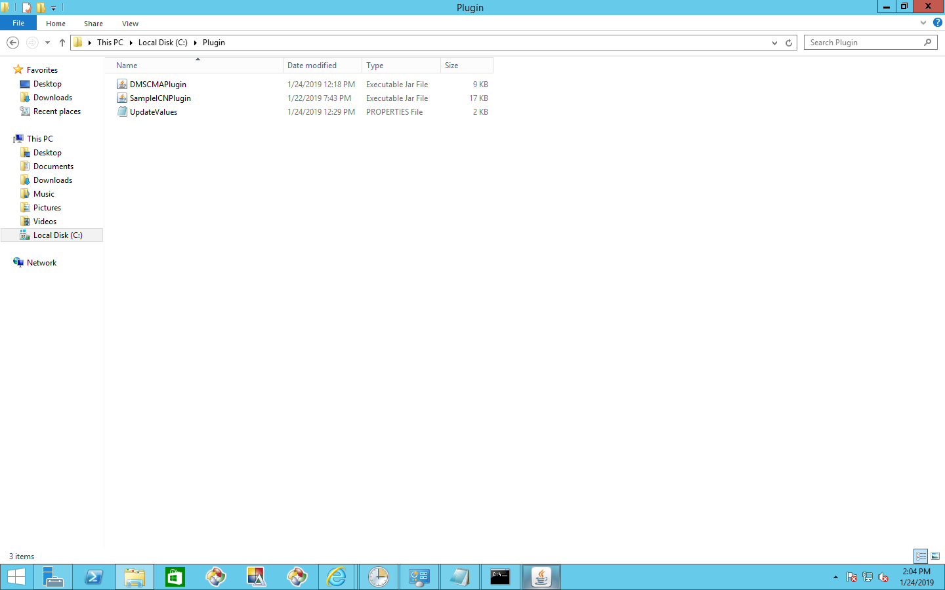

Load the above jar file in navigator and ‘save and close ‘

